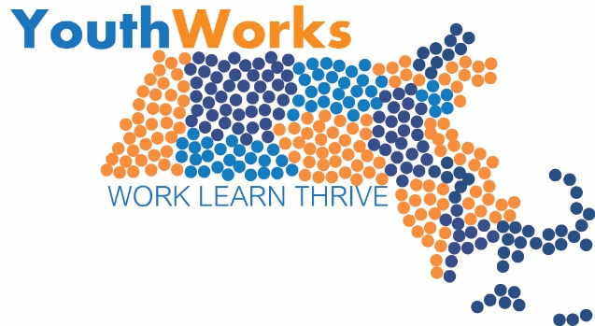

YouthWorks Year-Round Program 2018-19

Proposal Cover Sheet

Name of Lead Applicant Organization:
Fiscal Agent (if not lead applicant):_________________________________________________
Applicant Taxpayer ID# _________________________________________________________
Partners (if any) _______________________________________________________________
Project Manager Name:
Title:
Address 1:
Address 2:
City, State, Zip:
Telephone:
Fax:
E-mail:

Funding Option A or B __________________________________________________________
Total Funds Requested: $________________________________________________________

Total Number of Participants to be Served:___________________________________________

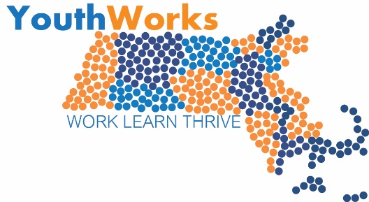

Program Narrative for 2018/19 Year Round

Sections 1-4 comprise the narrative section of the grant proposal
Proposals for Option A will be scored out of 100 and Option B will be scored out of 90 points.
- Program Overview – 10 Points
- Indicate whether you are proposing option A or option B
- Describe your program goals (Describe the choices you have made including what youth you are prioritizing, range of jobs/training you are developing, and types of performance goals you are setting).
- Describe your program partners and their proposed roles in the program design.
- Statement of Need – 10 Points (Only Required for Option A)
- What is the program model of your career pathway project and how was it developed?
- What sources of labor market information or economic development did you use to make decisions?
- Who has agreed to be part of your project advisory group to further develop the program design, vet applicable training models, and support successful implementation? Please name at least one industry partner who will provide input into the program design.
- Program Design (Implementation) – 30 Points
- Provide a description of the approach and format of the career pathway component. What are the major learning goals of the program and how will they be assessed? Please include list of performance goals. What credentials, if any, will be offered for youth participants? What kinds career exploration activities will be included (job shadow; field trip; interview practice with industry employers; etc.) and in what dosage? What will be provided to participants as part of transition activities and supports at the conclusion of the program? If the model includes occupational training, describe the following: Who will deliver the training and where will it take place? Describe the credentials and experience of the occupational trainer. What equipment and other training material will you provide or create?
- Provide a brief description of the format for delivery of the 20-hour Signal Success work-readiness component. What is the format for the work readiness component (e.g., weekly workshop, week-long training session, etc.)? Who will deliver the training? Where will the training take place?
- Provide a program staffing plan including youth supervision or case management (list roles and responsibilities for each staff member working in YouthWorks program). Detail how the case management will be similar and distinct from the case management approach used in previous summer and/ or year round YouthWorks sessions.
- For the employment component (if any), describe your strategy for employer outreach (including staffing structure for job development activities, what media/materials/events will be employed).
- Target Population – 10 Points
- Describe your strategy for youth outreach/selection. Include how both in-school and out-of-school youth will be recruited where relevant.
- Who will conduct eligibility determination? How will the flow of information be managed and documented such that youth eligibility will be determined in advance of the projected start date for employment?
- Budget and Budget Narrative – 15 Points
- Complete the project budget template and budget narrative.

- Program Summary and Timeline – 10 Points

- Anticipated start date(s) and end dates:
(include multiple dates if you have more than one cohort group)
- Anticipated youth occupational training dates:
- Anticipated youth employability training dates (20 hours of Signal Success):
- Timeline: please fill out the chart below describing all major project-related activities

Activity | Lead | Start Date | End Date | Desired Outcome/Product | How will Success be Measured?

- Planning Process and Projected Outcomes- 15 points
- Describe the major goals of your planning process. Explain how these goals will support successful current and/ or future implementation.
- Please fill out the chart below to describe your projected planning process.
Activity | Lead | Timeframe | Products Produced/ Milestones achieved

