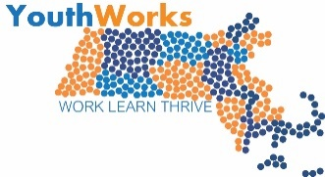
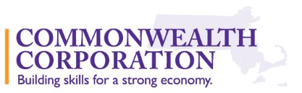
YouthWorks Year-Round 2017-18 RFP
Questions & Answers
Please submit your questions about the RFP to Anne Berrigan (aberrigan@commcorp.org) by July 14, 2017. We will post the final Q & A the week of July 17th.
- Do applicants have to choose to serve younger teens OR non-minors - but not both?
Applicants can serve teens ages 15-21. Programs can recruit younger teens and/or older teens. Targeting a specific age range, however, is recommended so that learning objectives can be appropriately developed for a particular age group.

- Can you serve youth from more than one of the targeted cities?
We prefer that applicants target youth participants in one city so that funding is used to the best advantage. More than one city might be possible in the instance where youth could get to one or the other city easily. In another example, if there were a shared technical skills instructor and related materials that could be used in more than one city, serving youth from more than one city may be possible.

- Does the project advisory group have to meet as part of the proposal development (i.e., before proposal is submitted)?
The advisory group does not have to formally meet prior to proposal submission. An industry partner can commit to helping during the planning process as part of the advisory group if the project were to be funded. At least one member of the project advisory should be an industry partner (this person could be a board member, at teacher, or school or program administrator, for example).

- How much time should we be spending on the "planning" period?
The proposal should show evidence of feasibility in terms of the technical skill focus and design of the training. Ideally, as result of this training, young people will be in a better position to get a job or understand how to get a job in the future. The occupational skill training should also match a local demand for talent. The planning process could take a couple of weeks to a month depending on time constraints of those involved. The program kick off meeting scheduled for October 25 will support the planning process as well.

- For the advisory group, does it need to be an independent person/organization or can it be made up of YouthWorks partners?
The advisory group can be made up of existing YouthWorks partners and/or people or organizations who have not had a prior role in YouthWorks.

- Can funds from this grant be used to pay the participants for their participation in occupational skill building training?
Funds can be used to pay participants for the skill building hours in the program. Due to labor laws related to apprenticeships and stipends, grantees must pay participants minimum wage for any training and work hours (the 20 hours of Signal Success training can be paid as well).
- Are the assessment tools developed by the program, or provided by CommCorp?
For the purposes of the proposal, it is not necessary to develop assessment tools. As part of the program design section of the narrative, applicants are asked to describe the main learning goals and how they will be assessed. For example, you may decide to use an observation rubric or performance indicators for teaching a particular skill. You do not have to submit the rubric. Commonwealth Corporation will have an opportunity at the October 25th kick-off meeting to provide technical assistance around assessment.

- Can you clarify what type of outcomes you are looking for?
In addition to process outcomes such as meeting recruitment, enrollment, and retention goals, we are looking to fund programs that will develop learning objectives and related outcomes. The technical skill focus would drive the content in terms of knowledge and skill acquisition. Outcomes should be performance-based so that young people learn how to apply skills and knowledge in a specific industry or work context. Establishing the criteria for participant success is an important part of the planning process.

