


Request for Proposals
for
Workforce Training Fund
Small Business Direct Access Program

Issued by
Commonwealth Corporation



RESPONSES DUE: January 30, 2018 by Midnight

Upload electronic submission to the following link:
https://commcorp.tfaforms.net/328722

CONTACT: Helen Witherspoon
Commonwealth Corporation
2 Oliver Street, 5th Floor
Boston, MA 02109
directaccess@commcorp.org
617-717-6926
FOR MORE RFP INFO: www.commcorp.org

FOR MORE WTFP INFO: http://workforcetrainingfund.org/

Small Business Direct Access Program

REQUEST FOR PROPOSALS

Section One: Grant Program Purpose & Structure

- About the Workforce Training Fund Program: The Workforce Training Fund is a state fund financed entirely by Massachusetts employers, and enacted into law in July 1998. Its purpose is to provide resources to Massachusetts businesses and workers to train current and newly hired employees. The mission of the Fund is to provide businesses with the resources to invest in the Massachusetts workforce and improve employee skills, and to maintain the economic strength and viability of the Commonwealth’s businesses.

- Purpose: Commonwealth Corporation is seeking applications from training providers to offer no cost training to payroll employees of eligible small businesses (100 employees or fewer) in Massachusetts that contribute to the Workforce Training Fund. This program is named the Small Business Direct Access Program.

- Context: Over the past several years, Commonwealth Corporation has been engaged in reviewing and redesigning Workforce Training Fund grant programs, application systems and grant management processes to provide businesses with a more streamlined, customer-focused experience. This year, based on customer feedback, we have been working on an initiative to improve Massachusetts’ businesses’ use-of and access-to the Express and Direct Access Programs. As a result, in Fiscal Year 2019 (July 1, 2018-June 30, 2019) we will be launching comprehensively redesigned Express and Direct Access Programs that will offer all Massachusetts businesses, regardless of size, with the opportunity to receive Workforce Training Fund grant support when they enroll their employees in publicly available training courses. The redesign will include the following changes to systems and programs:
- Rename the Direct Access Program the Small Business Direct Access Program and limit eligibility to companies with 100 or fewer employees in Massachusetts
- Expand eligibility for Express Program grants to businesses of any size
- Replace the TrainingPro Express Program application system and the Direct Access Program’s existing enrollment system with a single integrated interface to request grant resources for either program.
- The new system will also include an on-line training marketplace called the Massachusetts Training Exchange that will provide both businesses and training providers with a 21st century user experience.
- When the Massachusetts Training Exchange is fully functional, businesses will be able to search for courses by topic, compare prices see more detailed information about course content, and access user-reviews of training providers.
- Training providers will be able to post course outlines, competency objectives, sample materials and instructor profiles. They will also be able to deliver online courses in the new platform.
- The new system will also incorporate direct payments to providers including both grantee contributions, if applicable, and payment of grant funds.
- Businesses of any size will be able to determine eligibility, enroll in training courses, and request applicable grant funds through the training Massachusetts Training Exchange.
- Revised grant limitations including:
  - Eligible businesses may access up to $15,000 in grant funds per calendar year through the Massachusetts Training Exchange. Firms may be approved for up to $15,000 per year, whether via Express Program funds, Small Business Direct Access funds, or a combination of the two.
  - Eligible businesses may access up to $3,000 in grant funding per person, per course for all grant-funded training via the Massachusetts Training Exchange.

- How the Massachusetts Training Exchange will work with this program: Training providers selected through this Request for Proposals will list their Small Business Direct Access Program funded courses on the Massachusetts Training Exchange. They will market their courses to businesses and will direct all interested business to the Massachusetts Training Exchange to determine eligibility and to register for the course. First-time business users will be required to complete a registration process on the Massachusetts Training Exchange, including providing their Department of Unemployment Assistance number and uploading a Certificate of Good Standing.

Commonwealth Corporation will complete the eligibility determination process and communicate the business eligibility status directly to the business through the Massachusetts Training Exchange. Businesses will be able to browse courses and even register for courses before their eligibility is determined, but they will not be able to enroll in grant-funded training prior to being determined to be eligible.

All courses listed on the Massachusetts Training Exchange will be accessible to any size business. The size of the business seeking training, whether they contribute to the WTFP and their business’ year-to-date participation will determine the amount of the discount the business receives.
- Small businesses (100 or fewer MA employees) who are eligible for WTFP may participate in courses procured through the Small Business Direct Access Program at a 100% discount (i.e. 100% grant-funded).
- Large or small businesses who are eligible for WTFP may participate in all other courses at a 50% discount (i.e. 50% grant-funded, 50% out-of-pocket) through the Express Program.
- Any size business, regardless of WTFP eligibility may access courses listed in the Massachusetts Training Exchange out-of-pocket (i.e. no grant funding).

- Duration of Contract(s): Contracts are anticipated to be issued with a September 1, 2018 start date and are expected to end no later than August 31, 2020. Commonwealth Corporation reserves the right to discontinue funding at any time if there is insufficient evidence that the program or a specific grantee within the program is meeting established outcomes, including enrollment, attendance and completion rates.

Section Two: Eligible Applicants & Eligible Trainees

- Eligible Lead Applicants: The applicant must be a Massachusetts-based training provider with demonstrated capacity to deliver training to incumbent workers in one of the allowable training types outlined in Section 3. The applicant is not required to contribute to the Workforce Training Fund but must be in full compliance with all obligations to the Department of Unemployment Assistance, Department of Industrial Accidents and any other obligations to the Commonwealth of Massachusetts.

- Training Provider Responsibilities: Training providers will be responsible for the following activities:
- Work collaboratively with Commonwealth Corporation to ensure that the program achieves planned outcomes
- Register approved courses on the Massachusetts Training Exchange, with the support of Commonwealth Corporation staff
- Provide feedback on the course registration process during a beta test period from April 2018-June 2018
- Conduct general marketing and outreach to businesses to make them aware of the available training resources through the Workforce Training Fund, and specifically the Small Business Direct Access Program.
- Deliver scheduled training courses and maintain accurate attendance records
- Follow program protocol to submit pertinent information to Commonwealth Corporation at the conclusion of training.

- Eligible Trainees: Small Business Direct Access Program grant funds may only be used to train current or newly hired employees who work for a small business (100 employees or fewer in Massachusetts) that is located in Massachusetts and contributes to the Workforce Training Fund. Businesses with 101 or more employees are not eligible for the Small Business Direct Access Program, but may still participate in these courses at a discount of 50% through the Express Program.

All for-profit employers with payroll employees in Massachusetts contribute to the Workforce Training Fund. Some nonprofit organizations with payroll employees in Massachusetts contribute to the Workforce Training Fund, but others do not. This is determined by the method selected for UI coverage. Follow this link for more information. Nonprofits that use the “contributory method” are paying into the Workforce Training Fund and are therefore eligible to use this resource to train their employees. Nonprofits that use the “reimbursable method” are paying a discounted rate that does not include a contribution to the WTFP, and therefore are not eligible to use this resource to train their employees. Please note: government entities do not contribute to the Workforce Training Fund and are therefore not eligible to use this resource to train their employees.

These additional guidelines apply:
- $15,000 annual limit: All businesses that request training funds through either the Express Program or Small Business Direct Access Program are limited to $15,000 in grant funds per calendar year, effective calendar year 2019. This includes any combination of Express Program funding (i.e. 50% grant-funded, 50% out-of-pocket) and Small Business Direct Access Program (i.e. 100% grant-funded ) approved during any calendar year. Businesses will be provided with a dashboard in the Massachusetts Training Exchange that allows them to view their grant transactions and their remaining balance for the calendar year. Once the business has reached their $15,000 limit for the calendar year they will no longer be eligible to receive grant funding to cover the cost of courses until the start of the following calendar year. However, they may continue to use the Massachusetts Training Exchange to register for courses at full price.

[Please Note: There are no changes to the General Program training grant limits at this time.]
- All trainees must be working at an establishment located in Massachusetts, but are not required to live in Massachusetts.
- Only W-2 payroll employees of eligible businesses may participate.
- Participating companies must be in full compliance with all obligations to the Department of Unemployment Assistance, Department of Industrial Accidents and any other obligations to the Commonwealth of Massachusetts.
- Companies that have been debarred from doing business with the Commonwealth of Massachusetts or the Federal Government will be excluded from participating in this program.

Section Three: Program Design Requirements

- Training Type: Applicants must select one type of training they will deliver from the list of topics below. Applicants seeking to offer more than one type of training must submit a separate proposal for each type. Topics are listed in dark green and examples are listed to the right. :

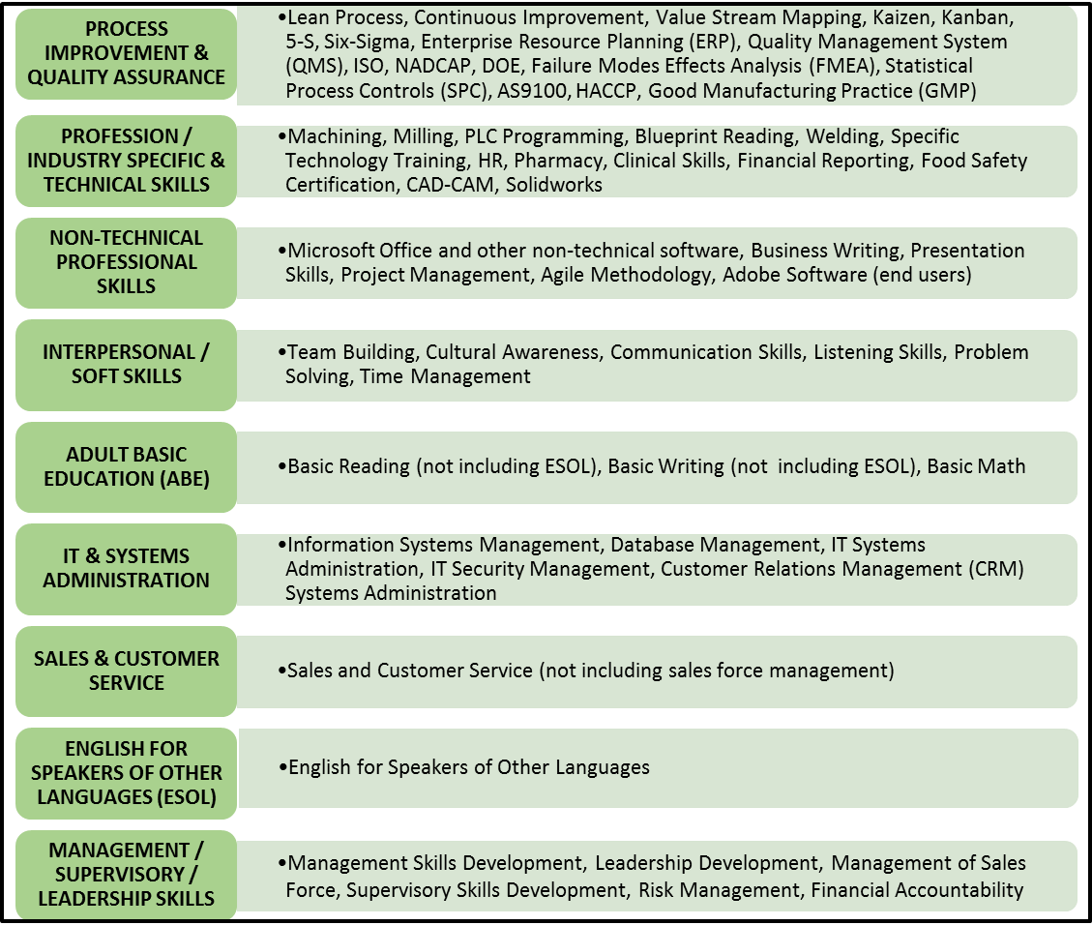

- Other Training Requirements: These additional guidelines apply:
- Applicants may only propose to deliver one topic of training (e.g. Process Improvement & Quality Assurance). Applicants may propose multiple courses that fall under a single training type.
- We are not seeking proposals to develop new training program/content or curriculum; applicants must propose courses that already exist.
- Applicants may not propose to provide training that is customized to meet the need of a single business or franchise of the same brand.
- WTFP funds may only be used to pay for the direct cost of delivering instruction. Grant funds may not pay for the costs of preparation, planning, travel, or consulting services. Training should apply best practices, be distinguishable from consulting services, reasonably priced and appropriate for proposed trainees. Grant funds may not be used to pay for any goods or services delivered prior to approval of grant funding.
- Applicants may only propose group training, not one-on-one training.
- Applicants may not propose training that is delivered exclusively self-directed. Self-directed instruction should only be included in a training design if it is complementary to other instructor-led instruction.
- All training locations must be Americans with Disabilities Act compliant.
- Applicants may offer training that is designed to serve a mix of both grant funded and non-grant funded enrollees.
- Training slots will be made publicly available on the Massachusetts Training Exchange and may be utilized by any small business that meets eligibility criteria on a first come first serve basis. Therefore, training providers should not commit slots to specific businesses prior to completing the enrollment process via the Massachusetts Training Exchange.

- Demonstration of Demand: Successful applicants will identify a region or regions from which they expect to recruit companies to enroll employees in their courses and will demonstrate that there is sufficient demand in the identified region to fill the training slots for each proposed course.

- Massachusetts Training Exchange Fees: In order to sustain the costs associated with operating the Massachusetts Training Exchange, each transaction will incur up to a 10% transaction fee. This amount will be deducted from the amount paid to training providers. Training providers may build this 10% fee into the cost of their course.

- Allowable Costs: Applicants must propose a cost per training slot for each course proposed to be delivered. This cost should include cost for instructors, supplies, materials, training space and up to 10% to cover fees associated with processing transactions on the Massachusetts Training Exchange. Training providers may not propose a cost per course fee that exceeds $3,000 per person. Other than an adjustment to account for system fees, pricing of courses procured through this RFP should be approximately consistent with course prices quoted elsewhere by bidders. The cost of occupational licensing is prohibited.

- Payment: Funds will be disbursed on a cost reimbursement basis, using the cost per training slot agreed upon in the contract. Training providers will be eligible to receive payment for a participant in a training slot only if the individual participates in at least 50% of the scheduled class hours. Grantees will be reimbursed only for expenses incurred during the period of the contract.

Section Four: Available Funding & Matching Funds

- Funding Availability & Grant Award Amount: Applicants may requested up to $250,000 per grant. Approximately $2.5 million is available for the Small Business Direct Access Program.

- Matching Funds: The applicant is not required to propose matching funds. Employers making use of the training supported through this program must pay employees their regular rate during training.

- Other Funding Sources: Applicants may not charge participating employers any additional fees (including but not limited to material fees) to participate in the proposed courses beyond the cost per trainee funded through this program. Training providers are encouraged to review all available funding sources to identify the grant program that is most aligned with the goals of participating businesses. If a single employer has sufficient demand for a General Program grant, training providers are encouraged to suggest that the company leadership consider applying to the Workforce Training Fund Program.

- Program & Fiscal Monitoring: Commonwealth Corporation is responsible for ensuring that organizations receiving grant funds:
- have the fiscal and program systems needed to meet all relevant federal and state requirements;
- meet the terms of the grant award outlined in the contract with Commonwealth Corporation;
- provide quality services to program participants; and
- expend grant funds only for allowable activities.

To fulfill this responsibility, Commonwealth Corporation will periodically request and review documentation. Additional information will be provided after a contract is awarded.

Section Five: Submission Schedule & Instructions for Submission

- Submission Schedule

Activity | Date
Request for Proposals Released | Tuesday, December 19, 2017
Deadline for written questions | Tuesday, January 23, 2018
Applications Due | Tuesday, January 30, 2018
Applicants Notified of Status | April 2018
Massachusetts Training Exchange Beta Test Period- Training Providers Load Courses | April –June 2018
Massachusetts Training Exchange Open for Business to Register | July 2018
Estimated Contract Start Date | September 1, 2018
Earliest Start Date of Courses | September 2018
Contract End Date | August 31, 2020

- Clarification Period: Questions about this grant program will be accepted in writing from December 19, 2017 through January 23, 2018. Please submit questions to Helen Witherspoon at directaccess@commcorp.org. All questions will be responded to and posted on Commonwealth Corporation’s website at www.commcorp.org. Applicants can sign up at https://commcorp.tfaforms.net/328721 to receive email notifications when new responses are posted. However, all potential applicants are advised to check the Commonwealth Corporation’s website periodically for additional information and updates until submissions are due.

- Application Submission Instructions: Grant Application Packages are due on January 30, 2018 by midnight. Please upload your submission electronically to the following link: https://commcorp.tfaforms.net/328722. In order to upload your submission, you will need to complete a form that provides the following information: (1) the Name of the applicant organization, (2) the applicant organization’s Federal Employer ID Number, (3) the applicant organization’s Department of Unemployment Assistance ID Number, (4) the Total Program Funds Requested, and (5) the applicant organization’s Primary Contact Person (to be notified upon decision of grant award).
Applicants should review all components prior to uploading in order to ensure they have completed all of the required information. Narrative forms must be submitted in MS Word file format. Should you encounter any submission issues, please contact Helen Witherspoon at directaccess@commcorp.org or 617-717-6926.

- Grant Application Package: The following attachments make up the required components of the Grant Application Package. Please provide the following forms and documents in the order in which they are listed.

Attachment 1: Application Summary Form
This form provides Commonwealth Corporation with summary level information about the proposed program. You may adjust the spacing as needed to accommodate your answers. This form should be the title page of your Grant Application Package.

Attachment 2: Application Narrative Form
This form provides a list of questions that applicants must address. Answer all the questions included on the Narrative Form. Do not change the order of the questions/sections. You may adjust the spacing in each section of the Narrative Form to accommodate your answers. Application Narrative Forms may not be in a font size smaller than size 11 and must have at least one inch margins. Application Narratives must be limited to 5 pages.

Attachment 3: Training Timeline Form
Complete the Training Timeline Form to include all proposed training activities.

Attachment 4: Budget Form
Attachment 4 is the Budget Form. Please list each course that will be provided. If you plan to offer a course more than once, please list it once and include the cumulative planned number of training slots over the 2 year grant period. The budget will also become the financial basis for any grant award. Commonwealth Corporation reserves the right to modify application budgets, prior to, and/or after grant award.

Attachment 5: Training Course Descriptions Form
Complete this form for each of the training courses listed in your proposal. Copy and paste this information into additional pages for each additional training course.

Attachment 6: Certificate of Good Standing
Applicants must submit a Certificate of Good Standing from the Department of Revenue that is less than 6 months old. Please follow this guidance when requesting and submitting a Certificate of Good Standing:
- The Department of Revenue’s Certificate of Good Standing is not the same and should not be confused with a Certificate of Incorporation issued by the Secretary of State’s office.
- This is a link to a sample C.O.G.S: http://www.mass.gov/lwd/docs/dcs/wtf/dor-cert-good-standing.pdf
- Please visit the Department of Revenue’s website (http://www.mass.gov/dor/businesses/programs-and-services/certificate-of-good-standing.html ) for more information about the C.O.G.S and to complete an online application to obtain a Certificate
- Applications for a C.O.G.S can take 4-6 weeks to be processed

Section Six: Submission Evaluation Process and Criteria

- Submission Evaluation Process: Submissions in response to this solicitation will be evaluated by a review committee which may include representatives from Commonwealth Corporation and the Executive Office of Labor and Workforce Development.

The submission review process will consist of the following steps:

Step 1: Threshold Criteria Screening
Submissions will be screened for completeness, conformity to the program requirements and timeliness of response. Submissions that are incomplete, non-conforming, or late will not be considered.

Step 2: Compliance Screening: Commonwealth Corporation will conduct an analysis to ensure the applicant is in compliance with state and federal law. Commonwealth Corporation will conduct the following reviews to ensure compliance:
- Confirm the applicant has met all tax liabilities. Commonwealth Corporation will conduct this screening by reviewing Certificates of Good Standing (C.O.G.S) submitted in the Grant Application Package.
- Ensure the applicant is in full compliance with all obligations to the Department of Unemployment Assistance, Department of Industrial Accidents, and any other obligations to the Commonwealth of Massachusetts.
- Ensure the applicant has not been debarred from doing business with the Commonwealth of Massachusetts or the Federal Government.

Step 3: Review Committee
The review committee will review and score all eligible submissions.

Category | Point value
Track record of success and qualifications/capacity of applicant to deliver proposed training | 15
Clear and realistic training plan | 20
Justification that the training will help businesses address a business goal or problem | 20
Demonstration of the demand for training in a specific geographic region | 15
Budget reasonableness and cost effectiveness | 15
The proposed training is likely to support increased skills for low-wage or low-skilled workers | 15

5 additional bonus points will be awarded to applicants that are certified by the Commonwealth’s Supplier Diversity Office as a Minority Business Enterprise (MBE), Women Business Enterprise (WBE), Veteran Business Enterprise (VBE) or Portuguese Business Enterprise (PBE). Information about certification can be found here https://www.mass.gov/supplier-diversity-office

Review results will be documented. Commonwealth Corporation reserves the right to request additional information from any applicant to ensure that the review committee has a complete understanding of the proposed program and applicant qualifications.

Step 4
All applicants will be notified of their award status by email in April 2018.

- Additional Evaluation Notes: In addition to the scoring system outlined above, Commonwealth Corporation reserves the right to only consider submissions that, in our sole judgment, are complete and responsive to the solicitation’s requirements and include all required application components. Additionally, Commonwealth Corporation and the Executive Office of Labor and Workforce Development reserve the right to consider other criteria in making competitive awards among comparably qualified applicants. Commonwealth Corporation reserves the right to reject any and all applications, or to accept any and all applications, in whole or in part, if deemed to be in the interest of the Commonwealth Corporation or the Commonwealth of Massachusetts to do so. The determination to approve or not approve an application for a training grant is not subject to appeal under any provision of M.G.L. c. 151A. (430 CMR 14.09) Appeals of the funding decision may be filed with Dr. J.D. LaRock, President, Commonwealth Corporation, 2 Oliver Street, 5th Floor, Boston, MA 02109. Appeals must be filed within fifteen days of the date of Commonwealth Corporation’s notice to unsuccessful bidders. The President may decide to hold an informal review of the decision, and may decide to grant an appeal, deny an appeal, or modify an award based on information provided during the informal review.

This submission does not commit Commonwealth Corporation to award any contracts. Upon submission, all applications become the property of Commonwealth Corporation.

- Audited Financial Statements and Verification of Fiscal Management Capacity: All applicants that are selected for an award must have demonstrated fiscal management capacity. Applicants may be required to submit a copy of the organization’s most recent audited financial statement prior to the execution of a final contract. In addition, prior to the grant award, Commonwealth Corporation staff may review an organization’s fiscal systems and internal controls to verify that the organization has the capacity to manage public grant funds and administer the program.

- Project Terms and Conditions: Applicants awarded funding will be required to abide by Commonwealth Corporation’s Standard Contract Terms and Conditions which will be provided during contract negotiation. Applicants may review these terms and conditions prior to submitting their application by contacting Helen Witherspoon at directaccess@commcorp.org to request a copy. In addition, all final contracts are subject to successful negotiation of a final statement of work and budget.

Section Seven: Summary of Attachments

- Grant Application Package
Attachment 1: Application Summary Form
Attachment 2: Application Narrative Form
Attachment 3: Training Timeline Form
Attachment 4: Budget Form
Attachment 5: Training Course Description Form

Attachment 1: Application form

Respond to all questions on the Application Form. You may adjust the spacing in each section to accommodate your answers. Do not delete any of the questions. Please note: This symbol ^ identifies information which you will also need to enter on the online submission form (see Section 5 for Submission Instructions).

1. Project Profile: Small Business Direct Access Program
Name of Lead Applicant Organization ^
Department of Unemployment Assistance ID Number ^ |  |  |  | Federal Employer ID Number ^
Cities/Towns Served by Program
Training Topic (From list in Section 3)
Grant Funds Requested
Lead Applicant Contact Information
Role | Name / Title |  | Address |  | Phone | Email
Primary Contact Person ^ (notified upon decision of grant award)
Authorized Signatory (authorized to commit organization)
Project Summary
In the space provided below, please provide a summary of your proposed project in 400 words or less. Please keep in mind that if your organization is awarded funding, this is the project summary that will be used in public announcements.

Attachment 2: Application Narrative Form

Please describe your project by responding to the questions below. Do not exceed 5 pages, using a font 11 points or larger and with at least one inch margins. The page limit does not include the other required Attachments of the Grant Application Package.

- List the training topic you propose to deliver (from list in Section 3).
- List the courses you will deliver that address skills associated with this training topic.
- If relevant, describe any relationship between these courses, including whether they are designed to be sequential and whether they lead to a credential.
- Please explain how the proposed training is likely to support increased skills for low-wage or low-skill workers?
- Where will training be delivered (organization and street address)? Is this location accessible according to the Americans with Disabilities Act?
- What are the business goals and problems that an employer may be trying to address if participating in this training topic? How will each training course help businesses address them?
- What geographic region will you serve through this program? If you are serving businesses throughout the state, indicate the region(s) that you have been (or are expected to be) most prominently served.
- Demonstrate the demand for the course(s) in this specific geographic region by completing the chart below. Please list each course you are proposing, the location(s) of where the course has been offered in the last year, the number of years your organization has offered this course, the number of times the course was offered in the last year, the number of individuals that participated in that course in the last year and the number of individuals employed at a small businesses (100 or fewer) that participated in the course in the last year.

Course Name | Location(s) of where course has been offered in last year | # of years course has been offered | # of times the course was offered in the last year | # of individuals that participated in that course in the last year | # of individuals employed at a small businesses (100 or fewer) that participated in the course in the last year

- Describe the track record and experience your organization has with delivering this type of training. List the names of the individuals who will provide training. For each individual, provide a brief summary of their qualifications.

Attachment 3: Training Timeline Form

Please list each training course that will be offered, in chronological order. If a training course will be offered multiple times please list each repetition of courses separately. If necessary, insert rows into the chart to capture all of the training courses that you plan to offer.

Start Date  (Month/Year) | End Date  (Month/Year) | Course Name | # Of Training Hours | # Of Grant Funded Slots

Attachment 4: Budget Form

Please list each course that will be provided. If you plan to offer a course more than once, please list it once and include the cumulative planned number of training slots over the grant period.

Course Name | # Of Training Hours | Planned # of Training Slots | Cost Per Training Slot | Total Cost Per Course

Attachment 5: Training Course Description Form

Complete this form for each of the training courses listed in your proposal. Add rows if there are more than 8 sub-topics. Copy this into additional pages for each additional training course.

Course Title
Total Course Hours
If relevant, list any industry recognized certificate or credential employees will earn as a result of participating in this course.

Sub-Topic 1
Estimated # of Hours
Description

Sub-Topic 2
Estimated # of Hours
Description

Sub-Topic 3
Estimated # of Hours
Description

Sub-Topic 4
Estimated # of Hours
Description

Sub-Topic 5
Estimated # of Hours
Description

Sub-Topic 6
Estimated # of Hours
Description

Sub-Topic 7
Estimated # of Hours
Description

Sub-Topic 8
Estimated # of Hours
Description

