2018-2019 Grantee Handbook
Bridging the Opportunity Gap (BOG) Initiative

Commonwealth Corporation strengthens the skills of youth and adults
so that they can thrive in the Massachusetts economy. By building their skills, we help businesses meet their workforce needs. We seed innovative solutions in response to critical labor market challenges through partnerships with industry, education and workforce organizations. Commonwealth Corporation is a Massachusetts quasi-public corporation within the Executive Office of Labor and Workforce Development.

For more information about Commonwealth Corporation, please visit our website www.commcorp.org.

Bridging the Opportunity Gap Grantee Handbook – Contents

Overview 1
Sources of Funding 1
Program and Fiscal Contacts 1
Program Management 2
BOG Requirements 2
Program Eligibility 2
Program Delivery 2
Data Reporting Requirements and Deadlines 3
Grantee Participation Requirement 3
Site Visits, Program Monitoring and Quality Assurance 3
Evaluations and Surveys 3
Grant Modifications 4
Positive Youth Development Framework 5
Fiscal Management 7
Fiscal Management: Invoicing and Payment 7
Allowable and Non-allowable Expenses 7
Documentation of Grant Expenses 8
Indirect Cost Rates 11
Grant Closeout 11
Program and Fiscal Monitoring 11
Miscellaneous Provisions and Requirements 14
Media and Communications 14
Information Security 14

Appendices
Sample Participant Referral Form
Sample Participant Sign-in Sheet
Sample DYS Youth BOG Program Weekly Timesheet Template
Sample BOG Gift Card Receipt Form

Overview

The Department of Youth Services is the juvenile justice agency of the Commonwealth of Massachusetts. The Bridging the Opportunity Gap (BOG) grant program has supported innovative transition and re-entry programming for youth ever since. Commonwealth Corporation, the state’s quasi-public workforce development agency, serves as the program administrator for these funds.
CommCorp and the DYS are providing grant funding for workforce development and employment during 2018-2019. These grant awards are the result of a competitive procurement. Selected grantees will deliver a range of career development, work readiness, subsidized employment, and related services for youth in the care of DYS.
Sources of Funding. Funds used to support the 2018-2019 BOG programs are sourced to an appropriation in the Massachusetts FY19 budget or the federal State Agency Program for Neglected and Delinquent Children, found in Title I, Part D of the Elementary and Secondary Education Act.
CommCorp Program and Fiscal Contacts. The two CommCorp staff members identified in the table below are the primary contacts for all grantees. Questions about program design, implementation, data reporting, etc., should be directed to the Program Manager. Questions about invoicing, payments, or fiscal monitoring should be directed to the Fiscal Contact.

Role | Name | Phone | Email
Program Manager | Danielle Niedzwiecki | 413-584-3627 ext. 205 | DNiedzwiecki@commcorp.org
Fiscal Contact | Dawn Wakelin | 617-717-6936 | DWakelin@commcorp.org

Program staff who will have contact with any DYS youth are required to adhere to all applicable DYS policies and procedures including, for example, those regarding safety and security, codes of conduct, dress codes, confidentiality, reporting of incidents, and photographs of DYS youth. The full range of current DYS policies is accessible on-line at http://www.mass.gov/eohhs/gov/lawsregs/dys/policies/ chapter-01-department-policies.html and should be reviewed by grantee so that its staff will be in full compliance with all guidelines and requirements;
Funded organization’s should review organization commercial insurance policy to ensure that BOG youth participants are covered for any loss or harm that may happen as a result of BOG related program activities.
Grantees should follow appropriate grant management procedures, including (a) submitting cash requests on a regular basis during the program; (b) regular submission of enrollment numbers, goals and services on a regular basis in the BOG database; and (c) timely contract closeout at the end of the season – submission of final invoices.
Transportation. When necessary, programs must arrange transportation to accommodate the needs of all the participants in the program to ensure that participants have a way to get to and from the program. This grant allows for transportation cost. Programs can provide vehicles, lease vehicles, and/or purchase transportation passes. CommCorp will cover the cost of transportation. However, grantees must include and submit transportation costs in the budget for approval.
Technical and Program Assistance. Commonwealth Corporation provides technical assistance to grantees of the Bridging the Opportunity Gap Initiative for the duration of the contract. Technical assistance is provided though the utilization of site visits, conference calls and workshops and trainings.

Goals of the Technical Assistance:
- Maintain contact with the contracting vendor to assure that the scope of work in the contract is successfully implemented.
- Maintain contact with the identified, collaborating DYS Regional and District office staff to assure that the youth targeted to receive services in the contract are receiving effective services.
- Serve as a point of contact on all questions regarding program implementation and data collection for the contract.
BOG grantees will participate in a minimum of three grantee working sessions to receive professional development training and to share program design and implementation activities throughout the program year. Attendance at these sessions is required for all grantees.

Program Management

BOG Program Requirements
Program Eligibility: Youth who are served using grant funds must be in the custody and care of the Department of Youth Services – specifically, youth who have completed their residential treatment and are in the community re-entry phase. Youth who have ‘aged-out’ of DYS (age 18 or age 21 for youth who have been committed as ‘youthful offenders’) must have signed a voluntary YES agreement (formerly called Assent of Ward) with DYS to be eligible for services under this grant. If during the enrollment process it is determined that a youth is going to “age-out” prior to the last three months of program’s end date, the grantee program coordinator should confirm with DYS staff that a YES agreement has been signed by the participating youth.
Program Delivery: Each grantee is obligated to deliver services as outlined in its approved grant scope of work, and use the BOG Tier program design that was outlined in the BOG Request for Proposals document. Your CommCorp Program Manager will remain in close communication with all program grantees, to help ensure that programs are consistent with the approved design, and that goals and outcomes are being met.
Data Reporting Requirements and Deadlines: Applicants awarded funding are required to collect and report participant-level data on participants and training services through a web-based database to be provided by Commonwealth Corporation. You will receive instructions on how to use the database. The database will include youth-level participation information. Some of the information we collect through the duration of the grant include: demographic information, participation, outcomes, and completions. Grantees are required to update the database on a regular basis.
Grantee Participation Requirement: Grantees must participate grantee sessions and webinars to receive professional development training and to share program design and implementation activities between the time period of October 2018 and June 2019. The dates, times, and locations of the working sessions and webinars will be provided after award notifications are made. Representation at all working sessions and webinars from each funded project is required. CommCorp reserves the right to reschedule or cancel any grantee working session or webinar with advance notice.
Site Visits, Program Monitoring and Quality Assurance: CommCorp staff will stay in close communication with grantees throughout the period of performance. Communication can take any of several forms – phone calls, convening grantees, technical assistance meetings, review of quarterly or periodic program reports, and on-site visits. Keeping close connections with a grantee helps assure ongoing collection of information to determine if programs are operating according to plan. From a larger view, such connections help identify opportunities that CommCorp can deliver technical support that helps grantees deliver program services and meet desired goals.
CommCorp staff will perform periodic site visits to each grantee. The purpose of these visits is to ensure that progress toward grant objectives and goals is being made, and to identify any technical assistance needs that CommCorp can provide to help ensure program success. A site visit may occur at any time during the period of performance. Local programs will be notified about site visits prior to the start of programs.
Evaluations and Surveys: CommCorp collects information from project participants and project sites to measure performance and effectiveness of your program. We measure success through data collection activities including a secure, web-based participant database, on-site visits from Commcorp technical assistance staff and three types of surveys (grantees, employers and youth). As the funding agency, CommCorp collects information about the experience of employers and youth for evaluation purposes and quality assurance. The information collected will help us continue to improve the program for grantees, youth and employers.
To learn more about the experiences of youth in the BOG programs, CommCorp will need help from programs with three efforts during the grant period:
• CommCorp will conduct anonymous surveys of all participating youth. The written survey aims to assess youth satisfaction with the BOG program and how the program has affected their attitudes and skills.
• CommCorp will ask you for a list of your employers who are supporting subsidized employment activities and our staff will conduct interviews with these employers.
• CommCorp will conduct an on-line survey of grantee staff to gather information that will assist us with program improvement and enhanced quality.
We recognize the sensitive and confidential nature of the data we collect and shall maintain the confidentiality of all information regarding project sites, trainees, project participants and their immediate families that may be obtained through data entry forms, databases, interviews, surveys and information collected during on-site visits. The information that is collected shall be used only as necessary to evaluate the performance of the program and be given only to specific persons working with CommCorp. No information that may reveal a participant’s identity shall be released without their permission. CommCorp complies with the provisions of the Fair Information Practices Act Ch. 776 of the Acts of 1975, and with CommCorp policy. CommCorp’s database is fully secured with firewalls to prevent unauthorized users from entering. The database has a SSL (Secure Sockets Layer) Certificate License for all servers that protect data when it passes over the internet between your computer and our server.
Information about DYS-involved youth participating in BOG programs should be kept strictly confidential. You can help make sure that youth data is private by doing the following:
• If you use paper registration forms or any other paper documentation with youth information on it, keep documents in a locked cabinet or office where only the project coordinator can access them and shred the documents at the end of the grant period.
• Do not share your database login and password with anyone aside from a designated data entry staff person.
• If you must write down your login and password, keep them in a safe place.
• Do not discuss a youth’s DYS status, living situation, and other private information with others unless there is a need to share information with specific BOG or DYS staff members.
Grant Modifications: During the course of your project, situations may arise that necessitate a change to the grantee’s contract with CommCorp. Such changes may be initiated by either a grantee or by CommCorp’s program manager. In some instances, a change must be executed through a formal contract amendment. In others, the change may be approved in writing by your CommCorp program manager without the need for a contract amendment. A grant contract modification is required if any proposed change affects:
• the total award amount;
• more than 10% of any approved budget line item, or shifting funds into a budget line item that was not funded on the approved project budget;
• the performance period (effective dates) of a grant contract;
• contract deliverables; or
• enrollment or outcome goals.
The following changes may be approved in writing by your CommCorp program manager without the need for a formal contract amendment:
• the program timeline;
• the type of education or training services provided; or
• the staffing plan, regardless of changes to the budget.
Note that the program manager may require a contract modification for any of the above-listed changes that constitute a significant revision to the project.
Grantees making unauthorized changes to a scope or budget risk incurring expenses that will be disallowed. Your CommCorp program manager can advise you on the appropriate documentation to submit with your modification request and any concerns they would like to discuss with you prior to finalizing a modification.
Once your program manager approves a modification request that requires a formal amendment, CommCorp will deliver a contract modification to the grantee to be executed by an authorized signatory.
If you have any questions about whether a change to your project requires a modification, we encourage you to consult your program manager to avoid making any unauthorized changes.

The positive youth development (PYD) framework focuses on the strengths and abilities of young people. The essential features of a PYD approach serve as a compass for designing the services, opportunities, and supports for the BOG programs.
Positive Youth Development Framework
While maintaining appropriate boundaries, program staff are able to help young people develop in multiple areas of growth – cognitive, social, cultural, emotional, civic, and employability.
The following table provides some suggestions for what a PYD approach might look like in a successful program. The recommendations are meant to support program-level discussion regarding the ways in which such PYD strategies can be best incorporated into your specific program. The suggestions are also meant to encourage us to be more conscious of how we work and interact with young people.
PYD Principle | Considerations for Practice
Youth gain both an understanding of and confidence in their abilities across multiple areas of growth. | Provide an empowering environment in which youth are able to frequently self-assess their progress.  Reward effort, creativity, and willingness to be open to new experiences. This will help youth better understand that trying, and sometimes failing, is an integral part of growth and can help move them towards both their short-term and more distant goals.  Encourage the youth to ask questions as they arise.
Youth have access to enriching opportunities and environments that foster a sense of control and optimism over their future. | Help youth become agents of their own change by engaging in discussions with them that help to define their sense of identity (who they are and who they can be in the world).  Consider focusing initially on “quick wins” – small, short-term, and achievable successes which help to build confidence and trust in working towards longer-term goals.  Hire staff who have experience working with a diverse group of young people and who reflect the demographic profile of the youth, as much as possible. Make an extra effort to hire bilingual staff members.  Check in with the youth to ensure that all participants feel safe in the program environment. Keep an ear out for any potential conflicts between members of the group and be prepared to intervene as necessary for the safety of the participants.
Youth have access to a multitude of opportunities that result in positive, caring, and committed connections. | Frequently and consistently interact with the youth by asking questions and engaging in conversation.  Make an effort to know every participant’s name (first and last) and confirm with the youth that you are pronouncing it correctly.  While maintaining appropriate boundaries, provide opportunities for youth to have positive interactions with their peers and with adults in the program whenever possible. Consider, for example, choosing activities that focus on team work versus individual competition.  Take time to reflect on how you’re speaking to a young person (tone, volume, word choice). Consider your intended message and reflect on the factors that might be influencing the way in which this message is or is not being heard by the youth.
Youth perceive some control over daily events and have a sense of accountability for their actions. | Offer youth multiple opportunities to have a voice in planning trainings, activities, or daily events in the program. Encourage the young people to set the high expectations of the activity, thus helping them develop a sense of accountability and pride in their leadership abilities.  Provide outreach and referrals to Adult Basic Education, literacy training, GED services and/or exposure to community college in order to help support goal achievement.
Youth are genuinely recognized for their efforts and progress. | Try to give multiple positive comments for every corrective piece of feedback you provide.  Highlight exemplars of youth work and share such successes through newsletters, bulletin boards, or other creative formats.

Fiscal Management
Fiscal Management: Invoicing and Payment: Upon receipt of a signed executed contract, CommCorp will create a customized Cash Request Form for your use in submitting an invoice for grant payment. This form will include your approved line item budget. All invoicing will be based on your organization’s expenses against the approved budget.
Keep the following in mind as you manage your program:
• Your organization’s system for tracking expenses and submitting a Cash Request Form should be on a cash basis, not an accrual basis.
• All CommCorp grant contracts are awarded as cash reimbursements. That is, CommCorp will reimburse your organization for expenses that are actually paid – you must first incur the expense before requesting reimbursement by CommCorp.
• Grantees may submit a Cash Request Form as often as necessary, but MUST submit one at least monthly.
• Submit your Cash Request Form to: Dawn Wakelin, Fiscal Staff, Commonwealth Corporation, 2 Oliver Street, Fifth Floor, Boston MA 02109. The invoice must be signed by a responsible official. Once signed, it may be scanned and submitted via e-mail (along with any backup documentation) to DWakelin@commcorp.org. Be sure to keep the original signed copy in your local grant files.
• CommCorp has a policy of ensuring that invoices are paid on a “net 30” basis. That is, we will pay your invoice within 30 calendar days of receipt. In most cases, your invoice will be paid much sooner than that.
• Submit detailed backup documentation with your first two invoices: All expenses must be supported with detailed documentation. You must submit copies of back-up documentation with your first two grant invoices. CommCorp staff will review the documentation and conduct a brief desk audit to make sure all expenses are supported with documentation. Grantees are encouraged to contact their CommCorp Program Manager to discuss any special situations that may arise, so appropriate documentation can support this expense. If your invoice documentation process goes smoothly, you may submit all subsequent invoices without the back-up detail – just make sure that you maintain the backup documentation at the your primary place of business in case CommCorp monitors your grant after the program has ended. In addition, CommCorp may periodically request copies of specific documentation.
Allowable and Non-allowable Expenses: Over the several years of administering BOG grants, grantees have raised questions about allowed and non-allowed expenditures. Your approved line item grant budget will reflect the guidelines listed below. Failure to obtain prior approval from Commonwealth Corporation for expenses outside and/or in excess of these guidelines may result in non-payment from Commonwealth Corporation.
Allowable expenses include:
• Clothing/uniforms for vocational programming/employment (maximum of $150 per participant)
• Transportation for youth participants
• Bus/train passes
• Van/bus rental (maximum of $3,000 during the grant period)
• Food for youth participants (that is calculated on a per participant basis by day);
• Youth stipends or wages – at a rate of $12 per hour
• Gift cards or other financial incentives (such as bonuses) for youth are permissible (maximum of $100 per youth for the duration of the grant period)
• Computer software (maximum of $500)
• Equipment rental (maximum of $200)
• Cell phone reimbursement for only the primary program staff person for the grant (maximum of $40 per month)
• Mileage for program staff (for the BOG grant) in relation to services rendered under the BOG grant. Reimbursement will be provided for mileage only (at the current reimbursement rate of the grantee’s fiscal agent)
• In some cases, GED testing fees and driver’s licenses/state identification may be expended with prior approval from Commonwealth Corporation. Grant program staff should request these funds first from DYS.
Non-allowable expenses include:
• Staff bonuses, incentives and/or gifts
• Equipment (defined as any item of tangible personal property having a per-unit cost greater than $5,000 and a useful economic life of more than three years). Property purchased with grant funds and used for grant purposes that does not meet the definition of ‘equipment’ would fall into the budget category of supplies and materials.
• Computers, cameras, iPods, televisions, DVD/VCR Player, computer hardware and/or accessories, laptops, furniture, etc.
• General/administrative costs that exceed 10% of the total budget
• Personnel costs that exceed 50% of the total budget (including fringe and subcontracted program staff)
• Mileage reimbursement not related to the BOG grant
• Any expenses in excess of the contracted grant amount or outside the contracted grant period
• Any expenses outside of the approved budget.

Documentation of Grant Expenses: Grants management and audit requirements of CommCorp’s funding sources require that we be able to account for and document all expenses charged/billed, and that all charges are real and allowable. Therefore, all expenditures that a grantee charges to a CommCorp grant must be supported with detailed back-up documentation. Failure to follow this policy and maintain and provide the required documentation when requested may result in corrective action. This will, at a minimum, require the grantee to submit full documentation with all subsequent invoices. In addition, previously-invoiced expenses may be disallowed if documentation cannot be produced for the item(s) in question. The table below lists the types of documentation acceptable for each category of expenses.

Expectations for Documenting Grant Expenses
Line Item | Acceptable Documentation
Project Staff Salaries (this includes program management, data entry, recruitment and all other program staff who deliver services and are directly charged to the grant award) | Proof of salary charges, such as a General Ledger payroll report or register; pay-period timesheets that detail the actual hours worked on the project, counter-signed by a supervisor.  Note: Staff from your organization who work on multiple grant funded projects must maintain a periodic timesheet documenting the actual hours worked on each grant funded project. There must be a direct chain that connects the number of grant hours reflected on a staff timesheet with a payroll amount charged to the grant on the organization’s accounting system.
Project Staff Fringe Benefits | Grantees can expense fringe benefits as a percentage of salary charges, but must document the basis for the Fringe Benefit rate – by either providing (a) a copy of an indirect cost rate agreement approved by a cognizant federal or state agency, if any; or (b) a listing that shows the components of fringe benefits that are included in the rate, and signed by the grantee’s chief fiscal officer or chief executive officer.
Travel | Grantees may be reimbursed for the payment of actual costs incurred in grant-related travel if this is an approved budget item. Such payments must be consistent with the grantee’s organizational policies on employee reimbursement.  Documentation must consist of photocopies of your organization’s Travel Voucher/Expense Reimbursement Form showing date, type of expense, amount of expense, employee signature, supervisor approval, and copies of all receipts. If your organization is selected for fiscal monitoring by CommCorp staff, you will need to provide a copy of your travel reimbursement policy.
Telephone & Communications | Grantee may be reimbursed for the actual costs of cell phone charges that are included in the approved budget and are relevant to the grant. Document with a photocopy of receipts or invoices, and show the basis for allocating that cost, plus an explanation of the apportionment to the project. Long distance charges may be highlighted and itemized on a monthly phone bill from your organization’s telecommunications provider.
Equipment Purchase | Not permitted.
Postage & Mailings | Grantee may be reimbursed for actual costs of postage, mailing, delivery, and shipping charges that are relevant to the grant. Document with a photocopy of receipts or invoices, and show the basis for allocating that cost, plus an explanation of the apportionment to the project.
Publications, Printing and  Copying | Grantee may be reimbursed for actual costs of printing, publications, and photocopying that are relevant to the grant. Document with a photocopy of receipts or invoices, and show the basis for allocating that cost, plus an explanation of the apportionment to the project.
Meeting Expenses | Grantee may be reimbursed for actual costs of meeting space, lodging, and food-related costs (if specifically allowed by the terms of the grant award) for training or other convenings that are part of the delivery of grant-related program services. Provide photocopies of all receipts or invoices.
Office Supplies and Materials | Grantee may be reimbursed for actual costs of office supplies and materials that are related to grant-related services. Provide photocopies of all receipts or invoices, and show the basis for allocating that cost, plus an explanation of the apportionment to the project.
Participant Support Services (e.g., transportation, clothing, tools) | Grantee may be reimbursed for the actual costs of payments made to youth or others for support services, bus passes, transportation, clothing and uniforms, tools, or other expenses that are a part of the approved delivery of grant-related services. All such costs must be documented with photocopies of receipts (for all payments made to vendors or other third-parties).  For awards to youth participants, grantee must provide documentation that shows the name of the youth receiving a payment, the purpose, the amount, the date, a signature of each youth showing that the payment was received, and a counter-signature of a representative of the grantee (employer/supervisor , program manager, or caseworker) acknowledging the delivery of the payment.
Gift Cards | Grantee may be reimbursed for the actual costs of payments to youth as payroll, work experience, stipends, or incentives, including any associated federal or state withholding taxes, FICA, etc.  For payroll, include copies of timesheets for each pay period included in the grantee’s invoice, signed by the youth and his / her supervisor. Include copies of payroll ledgers from your accounting system (or external payroll provider) and/or copies of cancelled paychecks.  For gift cards, grantee must provide documentation that shows the purpose of the gift card, name of the youth receiving a payment, a signature of each youth showing that the payment was received, the date of payment, and a counter-signature of a representative of the grantee (employer / supervisor , program manager, or caseworker) acknowledging the delivery of the gift card.

Consultants, trainers, and Other Professional Service providers or subcontractors | Grantee may be reimbursed for the actual costs of payments to consultants and other subcontractors. Grantees must provide a copy of a dated, itemized, and signed invoice from each contractor, countersigned by an authorized representative of grantee. The invoice from a contractor must clearly describe the product or service that was provided under contract. Grantee must be prepared to relate the expense to a required product or service described in your CommCorp grant award.

Indirect Cost Rates: The costs of administration are that allocable portion of necessary and allowable costs that are associated with the overall management and administration of the project and which are not related to the direct provision of workforce investment activities. These costs can be both personnel and non-personnel and both direct and indirect. Indirect costs are costs incurred for common or joint objectives that are not easily identifiable to a single cost objective and benefit multiple programs. Grantees may not charge more than 10% of costs as indirect costs. Grantees must submit each case request form (invoice) showing a simple, mathematical amount for indirect or administrative costs amounting to 10% of the total direct costs that appear in the invoice.
Grant Closeout: CommCorp will close out the award when all applicable administrative actions and all required work of the grant has been completed, or when the period of performance of a grant contract ends. Within 30 days after the expiration or termination of a grant, the grantee must submit all financial, performance, and other reports required as a condition of the grant. Upon written request by a grantee, the CommCorp program manager may extend this timeframe in writing.
Closeout events include:
• Submission of a final performance or progress report;
• Submission of a final invoice;
• Entry of all required data regarding program participants in the appropriate database or, with the permission of your CommCorp program manager, the alternative provision of required data fields in a readable electronic file; and
• An inventory of all equipment, if any, acquired with grant funds for which it is accountable
CommCorp will, within 30 days after a grantee completes its required closeout actions, make upward or downward adjustments to the allowable costs and make prompt payment to the grantee for allowable reimbursable costs.
CommCorp reserves the right to inspect program or project records, or to conduct a fiscal or program monitoring following grant closeout. A grantee must immediately refund to CommCorp any amount paid to it by CommCorp that is determined to be a disallowed cost.
Program and Fiscal Monitoring: Program Monitoring is undertaken by CommCorp staff to review specific program activities and operations. Basic monitoring data serve a preventive maintenance function, by reviewing key program elements such as participant attendance, number of program hours, and successful delivery of program outcomes such as subsidized employment or vocational training. For example, if absentee or student turnover rates reach a high level some immediate action may be required to stabilize the program.
In order to comply with CommCorp’s program expectations, all programs should maintain the following:

A. Program Records
• A daily participant log/list that is dated and can be shared weekly with DYS staff.
• Weekly timesheets that identify the date/hours and program component that are signed by youth and an authorized program staff member.
• A check payment log that is signed by the youth and program staff when checks are distributed to youth.
• A uniform log that is signed by the youth and program staff when uniforms/boots are distributed to youth
• A log of gift cards that include the purpose of the gift card and a youth and staff signature for distribution of cards.
• I-9 documentation (U.S. Department of Homeland Security Employment Eligibility Verification) for all participating youth and staff. The I-9 form and instructions are available on-line at http://www.uscis.gov/files/form/i-9.pdf.

B. Fiscal Recordsw
• A payroll ledger that accurately and clearly identifies all payroll payments made to youth and participating BOG staff
• Cancelled checks for all individuals listed on the payroll ledger
• Original receipts for all program expenses
Monitoring is a key step in ensuring that program resources entrusted by CommCorp’s funders are being spent appropriately for the purposes they were intended. We want to ensure full confidence that public funds in our care are being expended appropriately and efficiently. Accordingly, grantees are subject to fiscal and program monitoring of their grant and grant-funded activities. CommCorp’s monitoring is a process that assesses the quality of internal control performance, allowable expenditures and compliance with applicable laws and regulations.
Contract monitoring consists of a variety of activities that take place throughout each program period. Each time a grantee submits an invoice or Cash Request Form, the invoice is reviewed against the grant contract and approved budget. Overall spending patterns are assessed. Database reports, information from technical assistance providers, program issues and needs identified by grantees are also considered for performance and program delivery.
At CommCorp, we carry out fiscal monitoring to a selected subset of grantees each fiscal year. If a grantee is selected for an on-site fiscal monitoring, a CommCorp staff member will arrange a convenient time to conduct the monitoring. Typically, the grantee will be asked to provide a copy of a General Ledger report showing all expenses charged to the grant, organized by line item or budget category. A sample of expense items will be selected for full review – this ‘transaction testing’ comprises a significant portion of an on-site review. Monitors will examine a representative sample or cross-section of the items that make up the various classes of expenses. Sampling implies gathering evidence to use as a basis for making valid inferences about the characteristics of the population as a whole. The characteristics of most concern when conducting monitoring are the effectiveness of control procedures, the accuracy of transaction processing, the reliability of grantee records and systems, and the accuracy of account balances.
Our fiscal monitoring protocol consists of the following:
• General Ledger. Grantee must provide a copy of the General Ledger detail from its accounting software showing all expenses charged to the grant. Monitors will compare line item totals as expressed on the General Ledger report with invoices the grantee has submitted to CommCorp for grant payments. Monitors will investigate any variances by tracking individual expenses coded to the program.
• Payroll Testing and Consistency. Monitors will obtain all grantee payroll detail for both program staff and youth (if youth wages are a component of the program being monitored). Staff will compare payroll totals with General Ledger totals for wages and fringe benefits. Monitors will draw a sample of transactions to determine the connection between timesheet, payroll registers, and coding of wages and benefits in the General ledger account. Monitors will identify specific pay period(s) and review copies of timesheets, payroll ledger/register, and reconcile payroll to the Ledger and to the invoice.
• Other Expense Items. Monitors will sample a subset of transactions in other budget categories (e.g., supplies, travel, consultants) and test all related back-up documentation. Monitors will reconcile expense entries to invoiced amounts. In some cases, monitors will also obtain copies of grantee finance, HR, and employee policies to determine the consistency of sampled transactions with the stated policy of the organization.
Some expenses for some grantees are made on an allocated basis – rent, utilities, MIS, and indirect costs are examples where allocated costs are a common way organizations use to allocate operational expenses across multiple grants or funding streams. Monitors may review cost allocation plans to determine when expenses are allocated, the methods used in allocation, to verify that expenditures are allocated in accordance with the plan, and to ensure that allocated costs expensed to a CommCorp grant are reasonable.
If an indirect cost rate is used, monitors will verify that the rate has been approved by an appropriate cognizant agency and that the rate has been properly applied to the program. If an indirect cost rate is not used, monitors will review the level of administrative overhead applied to the contract, verify the costs that serve as the basis for the rate and verify that the rate is being properly applied and appropriately updated. Monitors will also ensure that the costs that are part of the overhead rate are not also being directly charged.

Miscellaneous Provisions and Requirements

Media and Communications: DYS requires each grantee to adhere to DYS policies and practices related to the use of images of youth committed to the Department’s care. A grantee organization may not photograph or take video of any DYS clients, facilities, employees, or identify clients in any manner, in any publications without prior signed written approval of the department in advance of taking of any photographs or video of young people. Additionally, all press releases associated with any project that mentions DYS or a DYS young person must be approved by the DYS Central Office in advance of contact with the press. Please contact the BOG program manager or your TA to assist you in obtaining approval.
Information Security. Several recent actions by the Massachusetts General Court and the Governor affect information security – making sure that personal and private information of individuals is safeguarded against unauthorized disclosure. CommCorp and all of its grantees and sub-grantees are required to follow all reasonable and appropriate security procedures and practices necessary to protect personal information related to clients, customers, applicants or participants from unauthorized access, destruction, use, modification, disclosure, or loss.
Your grant agreement includes provisions regarding information security. We urge you to read and comply with all of the security policies issued by the Commonwealth of Massachusetts, and to ensure full compliance by your employees, contractors, sub-grantees and subcontractors. If you become aware of any event that involves unauthorized disclosure or destruction of personal information, you are required to notify CommCorp and take further steps to avoid an additional breach of security.
CommCorp has policies and controls in place to provide reasonable assurance that security objectives are addressed. Our written information security policy is part of a comprehensive program that ensures that we:
• Collect quantity of personal information and data reasonably needed to accomplish legitimate purpose
• Securely store and protect personal information and data against unauthorized access, destruction, use, modification, disclosure and loss
• Disclose personal information and data only on a need to know basis
• Destroy personal information and data as soon as it is no longer needed or required to be maintained under state or federal law
• Address administrative, technical, and physical safeguards

CommCorp has incorporated information security requirements into all grant agreements. For example, a form titled Contractor Certification of Compliance with Commonwealth Corporation’s Information Security Policy is a part of your executed grant agreement. The policy is available at www.commcorp.org/ documents/CommCorpInformationSecurityPolicy03-01-2010.pdf.

Sample BOG Program Referral Form
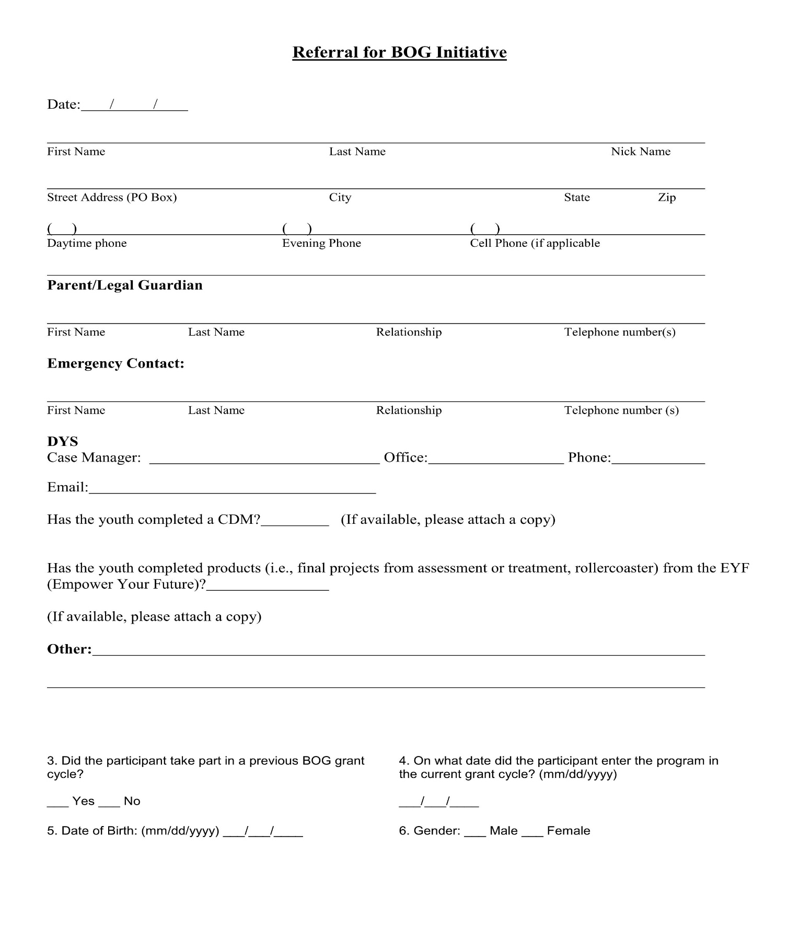

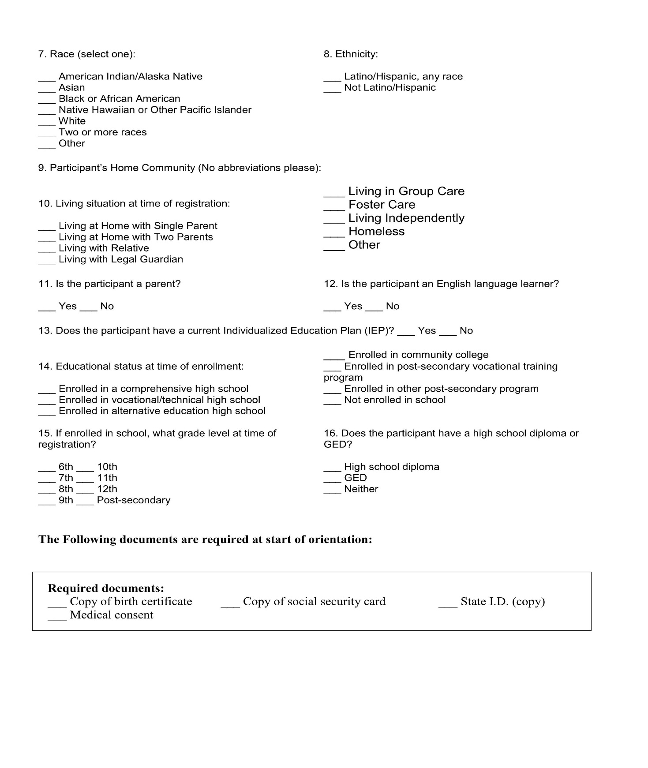

Sample Participant Sign-In Sheet

Signature of Participant: Time Signed in:

Site Supervisor’s Signature Date
Sample DYS Youth Employment Program Weekly Timesheet Template

Participant’s Name Calendar Week Ending

Day | Date | Time In | Time Out | Total | Participation
Sunday |  |  |  |  | Absent ☐ Punctual ☐ Professional ☐ Engaged ☐
Monday |  |  |  |  | Absent ☐ Punctual ☐ Professional ☐ Engaged ☐
Tuesday |  |  |  |  | Absent ☐ Punctual ☐ Professional ☐ Engaged ☐
Wednesday |  |  |  |  | Absent ☐ Punctual ☐ Professional ☐ Engaged ☐
Thursday |  |  |  |  | Absent ☐ Punctual ☐ Professional ☐ Engaged ☐
Friday |  |  |  |  | Absent ☐ Punctual ☐ Professional ☐ Engaged ☐
Saturday |  |  |  |  | Absent ☐ Punctual ☐ Professional ☐ Engaged ☐
Total Hours For The Week:

Absent | Punctual | Professional | Engaged
If youth was scheduled to attend but called out/no call-no show | The youth arrived on time for scheduled shift/event | - Dresses according to the norms of the environment  - Uses appropriate language, volume, clarity and tone based on the norms of the environment.  - Uses friendly tone and smiles when conversing with others  - Is on task and focused  - Following through on expectations  - Respectful and positive attitude  - Able to self-manage time | - Paying attention  - Does not use cell phone  - Focused and participating in conversation and setting goals  - Actively pursuing goals  - Keeps in communication  - Completing tasks through to completion
I hereby certify that the information included on this timesheet is true and correct.

Participant’s Signature Date

Site Supervisor’s Signature Date

Program Director’s Signature Date
Sample BOG Gift Card Receipt Form

Name of Participant | Signature of Participant | Amount of Gift Card | Date

Program Supervisor’s Signature Date

