**APPLICATION SUMMARY FORM GUIDANCE**

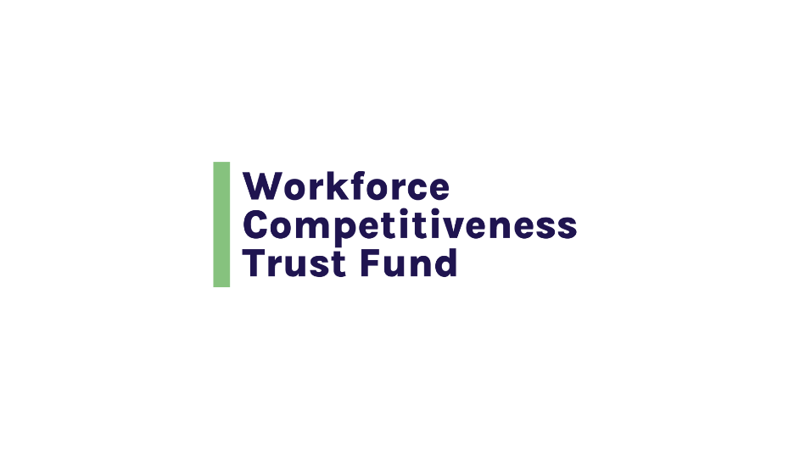

**INTRODUCTION**

**Purpose of the Application Summary Form**



The application summary form provides a high-level review of the application for the reviewer, including information about the applicant, the region, the programmatic focus (occupation and target population), the start and end dates, the amount requested, the scale of the program and the partners, including employers (two or more employer partners are required).

We recommend that you complete the Summary Form after you have completed all other application documents. The information provided in the Summary Form should match the information in the Application Program Narrative, Budget forms, MOA, and Certificate of Good Standing. Reviewers will note any differences and may delay your application.

Information from the Application Summary Form will be used in any public funding announcements.

**SECTION 1** 

**Partnership Profile**



**Applicant Identifiers:**

This section begins by asking for

* the name of the lead organization
* the organization’s Department of Unemployment Assistance ID number
* the Federal Employer ID Number (FEIN)

Any organization operating in the Commonwealth of Massachusetts will need to have both of these ID numbers. The lead organization is the organization that is submitting the grant application.

If the application is approved for funding, the lead organization will be the grant recipient and will be issued a contract to manage all of the activities proposed in the application.

**Applicant Type:**

This response provides the reviewer with information about the lead applicant and its primary purpose.  Use a check box to indicate the lead applicant’s type of organization. The options are:

* Community-Based Organization – a non-profit organization based in the community and providing services for that community
* Employer – operating as a business in Massachusetts, either as a for-profit or non-profit business
* Employer Association – organization representing members that are employers, often within a particular industry
* Higher Education Institution – operating as an accredited educational institution with postsecondary programs. Generally, a two-year college or four-year college or university.
* Labor Organization – a Union or a Union Apprenticeship program
* Local Workforce Development Entity
* Local Workforce Board – a MassHire Workforce Board, representing one of the 16 Workforce Regions in the Commonwealth. You can find information about MassHire Workforce Boards and Workforce Regions [here](https://www.mass.gov/info-details/connect-with-your-local-masshire-workforce-board).
* Nonprofit Education, Training, or Other Service Provider – a non-profit entity providing workforce development services not targeted to a particular community
* One-Stop Career Center – a MassHire Career Center. You can find information about MassHire Career Centers [here](https://www.mass.gov/masshire-career-centers-for-jobseekers).
* Vocational Education Institution – a career and technical high school

Please indicate the blueprint region represented by the lead MassHire Workforce Board:

This answer should be consistent with your response to Section 1A: Indicate your Blueprint Planning Region of the Application Program Narrative. Please provide the region that your program will be serving. There are seven blueprint regions in Massachusetts:

* Greater Boston – includes Boston, Metro North and Metro SouthWest MassHire regions
* Southeast – includes South Coast, Brockton, New Bedford and Bristol MassHire regions
* Northeast – includes North Shore, Greater Lowell and Greater Lawrence MassHire regions
* Central – includes Central and North Central MassHire regions
* Pioneer Valley – includes Hampden County and Franklin Hampshire MassHire regions
* Berkshires – includes the Berkshire MassHire region
* Cape and the Islands – includes the Cape and the Islands MassHire region

**Program Name and/or Partnership:**

Provide the name of the program for which you are applying for funding:

**Which Program Categories are you Applying To:**

Use a check box to select one of the three categories:

* Training and Placement Program – training and placing unemployed and underemployed individuals for new jobs in the target occupations
* Training and Advancement Program – providing occupationally focused skills training for individuals who are already working in the industry (incumbent workers) to advance into a target occupation that pays more than they are earning in their current position
* Hybrid Training Program – A mix of Training and Placement (unemployed and underemployed individuals) and Training and Advancement (incumbent workers)

**Target Industry/Occupations:**

Provide the occupation your program will prepare individuals for. List a single occupation, unless the training required is identical for more than one occupation.  This answer should match the information you provide in your Application Program Narrative submission, Section 1C. Also provide your employer partners’ industry or industries.

**Proposed Duration of this WCTF-Funded Program:**

There are two options for WCTF grants: two years or three years.  Use a check box to select the one that applies to your program. This should be consistent with the Training Timeline you provide in Section 9 of your Application Program Narrative and the information provided in your Budget.

**Preferred Grant Start Date:**

Indicate the date that you would prefer to start your program. We recommend that you plan on a start date that is no earlier than 4 to 6 months following the application due date.

**Preferred Grant End Date:**

If you are requesting a two-year grant, the end date should be two years after the start date.  If you are requesting a three-year grant, the end date should be 3 years after the start date.

**Total Implementation Funds Requested:**

Please indicate the **total amount** of funding that you are applying for from the WCTF. This should match your Budget documents.

**Proposed # People Enrolled:**

Please provide the total number of individuals you plan to enroll over the course of your 2- or 3-year grant. This should match the number you provide in the Training Timeline in Section 9 of your Application Program Narrative. It should also match the number you use to calculate the Overall Cost per Participant Served (Enrollment) on your Program Budget Summary Form.

**Proposed # Completions:**

Please provide the total number of enrollees you project will complete the program over the course of your 2- or 3-year grant. This number should match the number you provide in the Training Timeline in Section 9 of your Application Program Narrative.

**Proposed # Placements (Option A/C):**

If your Program Category is either Option A or Option C, please provide the total number of enrollees you project will be placed into a training-related job over the course of your 2- or 3-year grant. This number should match the number you provide in the Training Timeline in Section 9 of the Application Narrative. It should also match the number you use to calculate the Overall Cost per Employment Outcome (Placement) on your Program Budget Summary Form.

**Proposed # Wage Increases (Option B/C):**

If your Program Category is either Option B or Option C, please provide the total number of enrollees you project will receive a training-related wage increase over the course of your 2- or 3-year grant.

Does your proposal contain any of the following elements? Check all that apply.

Commonwealth Corporation encourages applicants to include one or more of these elements in their proposals   Section 3 (pages 15 and 16) of the WCTF/Donnelly Grant RFP provides detailed guidance.

**SECTION 2** 

**Program Summary**



Provide a brief description of your proposed program in 400 words or fewer. This summary will be used in any public announcements of funding. Please include the program name, the length of the training program and occupational focus of the program, the target population, a brief description of the training components and timeline, the planned number of enrollments, completions, and placements and any other relevant information that you would like to highlight should the program be funded.

**SECTION 3** 

**Lead Applicant Contact Information**



**Please provide the name and title, address, phone number and email address for the following individuals at the Lead Application Organization:**

* Primary Contact Person. This is the person Commonwealth Corporation will contact to inform you whether your application has been selected for a grant awarded
* Authorized Signatory. This is the person who is authorized to commit the organization (sign contracts).
* Fiscal Contact. This is the person who will be responsible for managing grant program funds and submitting invoices if your organization is awarded a grant
* Project Manager. This is the person who will be responsible for managing grant operations over the course of the program if your organization is awarded a grant. This individual will be the primary contact for Commonwealth Corporation during the grant period. The name of the Project Manager should be consistent with the name of the Project Manager listed on the Internal Staff Summary Sheet of your Budget Form.

**SECTION 4** 

**Partnership Members and Contact Information**



**The organizations listed in this section should be consistent with the organizations listed in**

* your MOA or signed Letters of Commitment,
* Sections 1E1, 4A, 5A, 6A, 7A of your Application Program Narrative and,
* the Grant Request Narrative Form and Contracted Services Sheet of your Budget (if you are subcontracting with any of the partners).

Include information for your required partners and all other partners. You are required to have at least two employer partners with operations in Massachusetts that employ residents in the targeted occupation.

For each partner, please provide the organization type (use the categories in Section 1, Applicant Type), the organization’s name and address, and the name, title and email of the individual representing the partner organization.