**EMPLOYER**

**ENGAGEMENT TOOL**

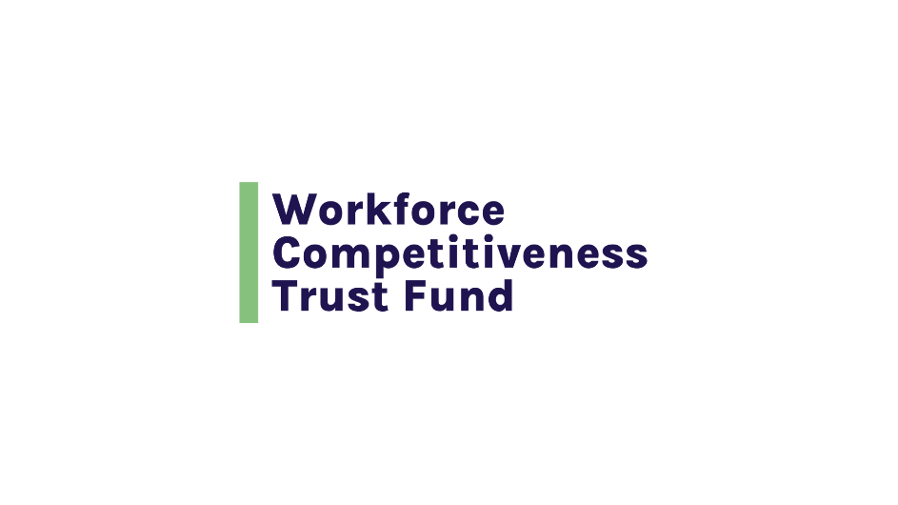

**INTRODUCTION**

**A Guide to Employer Engagement**

**Employer engagement is central to building an effective sectoral employment program partnership and program design.  The objectives of Employer Engagement include:**

* Securing a clear and comprehensive understanding from partnering employers about hiring demand, employer pain points and hiring requirements for the targeted occupation
* Preparing participants to gain the skills and experiences required to be hired into the position and navigate their future career path
* Leveraging the knowledge and resources of partnering employers for the benefit of participants and the program; and
* Meeting the talent needs of employer partners for the targeted occupation

**This tool is designed to help you plan and manage your employer engagement activities through 7 phases:**

**Step 1** → Identify Potential Employer Partners

**Step 2** → Develop Your Outreach Strategy and Messaging

**Step 3** → Gather Information about Hiring Demand, Requirements and Job Quality Indicators

**Step 4** → Determine How You Want to Engage Employers at Each Stage of Your Program

**Step 5** → Formalize the Relationship through an MOU

**Step 6** → Structure and Strategies to Sustain and Grow the Relationship

**Step 7** → Develop Your Employer Engagement Management Plan

**STEP 1**

**Identify Potential Employer Partners**

**Who are local employers that have vacancies in the target occupation and are likely to provide good jobs as measured by pay, benefits, working conditions, DEI commitments and advancement opportunities?**

|  |  |
| --- | --- |
| **QUESTIONS** | **ANSWER HERE** |
| Identify employers through job boards and hiring platforms such as Indeed and JobQuest |  |
| Tap into your organization’s connections to the industry through Board members and volunteers |  |
| Examine employer websites and job postings to glean information about the number of job vacancies and job quality indicators such as salary, benefits, hours and locations |  |

**STEP 2**

**Develop Your Outreach Strategy and Messaging**

**What is your employer outreach strategy and messaging?**

|  |  |
| --- | --- |
| **QUESTIONS** | **ANSWER HERE** |
| How many employer partners are you seeking? What roles are you asking them to play? |  |
| What is your program’s value proposition? What employer pain points will your program address? How will your program benefit participants, employers, the industry and the broader community? What is your vision of success? |  |
| What is your elevator pitch that you will use to communicate your partnership’s value in outreach efforts? |  |

**STEP 3**

**Gather Information About Hiring Demand, Requirements and Job Quality Indicators**

**What do you need to learn from employers about their demand and hiring requirements and indicators of job quality?**

|  |  |
| --- | --- |
| **QUESTIONS** | **ANSWER HERE** |
| Develop a template for capturing this information |  |
| [See](https://commcorp.org/wp-content/uploads/2017/06/Blog_RL_Questions-to-Ask-Employers-About-Occupational-Demand-003.pdf) as a resource for guiding your employer conversations |  |

**STEP 4**

**Determine How You Want to Engage Employers at Each Stage of Your Program**

**How do you want to engage employers at each stage of your program?**

|  |  |
| --- | --- |
| **QUESTIONS** | **ANSWER HERE** |
| Program Design |  |
| Outreach, Assessment and Screening |  |
| Training Delivery |  |
| Work-Based Learning Opportunities |  |
| Job Placement |  |
| Job Retention and Advancement |  |
| Governance, Learning and Redesign |  |
| Sustainability |  |

**STEP 5**

**Formalize the Relationship through an MOU**

**Secure employer commitments through a Memorandum of Understanding**

|  |  |
| --- | --- |
| **QUESTIONS** | **ANSWER HERE** |
| What are the roles and responsibilities, and commitments of each employer partner? (See examples below) |  |
| What are your organization’s roles, responsibilities and commitments? Other partners? |  |
| Will you codify the roles, responsibilities and commitments through Letters of Commitment or an MOU? What needs to be included in either document? |  |

**Examples of Employer Partner Roles and Commitments**

|  |  |
| --- | --- |
| **PROGRAM ELEMENT** | **EMPLOYER ROLE AND COMMITMENTS** |
| Program Design | Providing information about vacancies, hiring requirements and indicators of job quality such as salary and benefits |
| Outreach, Assessment and Screening | Providing input about hiring requirements that are non-negotiable  Participating in candidate assessment and selection  *There are some program models in which employers hire candidates before they start training |
| Delivery of Training | Guest speaker  Tours of facilities  Job shadows  Adjunct instructor |
| Work-Based Learning | Internships and Co-ops  Apprenticeship |
| Job Placement | Resume Review  Mock Interviews  Commitments to interview graduates  Commitments to hire qualified graduates |
| Governance | Serve on program board or advisory committee |
| Sustainability | Is a champion for the program with other employers and funders |

**STEP 6**

**Structures and Strategies to Sustain and Grow the Relationship**

**What formal structures and strategies will you use for ongoing employer and business partner discussions, learning and program refinements?**

|  |  |
| --- | --- |
| **QUESTIONS** | **YOUR DATA COLLECTION PLAN** |
| How will you routinely get employer feedback about the program? |  |
| How often will you connect with employer partners to keep them informed and gather their insights? |  |
| How will you ensure that the program is up-to-date in terms of hiring requirements as the industry evolves? |  |
| How will you build the relationship along a continuum of transactional activities to strategic activities (see chart below) |  |

**Employer Engagement Continuum**

Relationship may start as transactional or partner; some will move to stakeholder

Transactional (Informal, reactive)

* Responds to requests to interview candidates
* Provides feedback on candidates
* Shares information on vacancies

Partner (Intentional, proactive) MOU or LOC

* Shares information on skill requirements and hiring processes
* Commits to interviewing and providing feedback on candidates
* Provides input into program design
* Participates in program delivery
* Clearly designated points of contact in each organization (program and employer)
* Regular check-ins to identify opportunities for improvement

Stakeholder (Intentional, proactive, future-oriented) MOU

* Interviews prospective program candidates and may hire candidates before the program starts
* Participates in designing program content (identifying core competencies, developing competency assessment methodologies)
* Participates in program delivery, including speaking, teaching, on-the-job training, and work-based learning
* Commits to interviewing graduates and may commit to hiring qualified graduates
* Provides systematic feedback about program quality and updated information about hiring requirements
* Participates in strategic planning and partnership and resource development

**STEP 7**

**Develop Your Employer Engagement Management Plan**

**What staffing do you need to carry out, sustain and grow employer engagement? What budget do you need?**

|  |  |
| --- | --- |
| **QUESTIONS** | **YOUR PLACEMENT SERVICES STAFFING PLAN** |
| Who will lead employer engagement efforts for the partnership? What skill sets do they need to effectively carry out this work? | **QUESTIONS** |
| What budget do you need to carry out employer engagement efforts? Do you need to cover any costs in addition to staffing? |  |