**PLACEMENT SERVICES PLANNING TOOL**

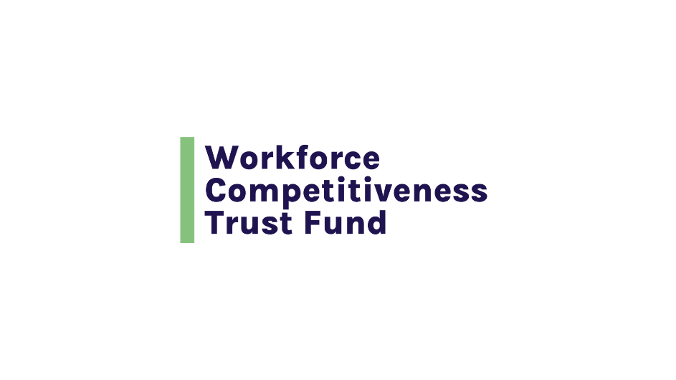

**INTRODUCTION**

**Placement Services Planning Tool**

**The objective of placement services is to ensure that participants can:**

* Develop a resume and complete an application, including online applications and
* Successfully conduct job search activities and
* Find a good job related to the training program that they completed.

**This tool is designed to help you plan and manage your placement services strategy through six phases:**

**Step 1** → Identify Participants’ Placement Services Needs

**Step 2** → Identify Employers’ Recruitment and Hiring Needs and Processes

**Step 3** → Design Your Placement Services Model

**Step 4** → Identify Placement Services Partners and Build Relationships with Employers

**Step 5** → Develop a Partnership Agreement and Memorandum of Understanding with Employers

**Step 6** → Develop Your Placement Services Management Plan

**STEP 1**

**Identify Participants’ Placement Services Needs**

**List the likely placement services needs of enrollees, based on knowledge and previous work with the target population.**

|  |  |
| --- | --- |
| **QUESTIONS** | **ANSWER HERE** |
| These might include:  Career interest assessments and inventories  Training that supports them in:  Documenting their work history and summarizing their skills, knowledge and attributes  Completing online and in person job applications  Developing a resume  Developing a cover letter  Interview skills  Following up on applications  Developing and working their networks |  |
| Review the list of likely placement services needs with partnering organizations and instructors and validate with review of assessment information.   * Do partnering organizations and instructors agree with the list and/or add any likely services? * What, if any, are additional services suggested by partnering organizations and instructors? * Does preliminary information about your target population suggest other placement service needs? |  |

**STEP 2**

**Identify Employers’ Recruitment and Hiring Needs and Processes**

**List local employers who have vacancies in the targeted occupation and/or skillset in the local labor market**

|  |  |
| --- | --- |
| Identify employers who are likely to provide good jobs as measured by pay, benefits, working conditions and advancement opportunities. |  |
| Identify employers who are offering good jobs with whom you have connected and who are interested in partnering with your program. |  |
| Identify employers who are offering good jobs who you would like to connect with to develop a referral and placement relationship. |  |
| Develop your employer outreach strategy and messaging. |  |

**Building from the list of employers hiring for the targeted occupation and skillset and offering good jobs, document their hiring needs, preferences, processes and timelines.**

|  |  |
| --- | --- |
| What is their application process? |  |
| When do they hire? Is it seasonal? |  |
| What are they looking for in a candidate in terms of skills, knowledge, experience, and attributes? |  |
| Do they require any certifications or licenses? |  |
| What gives a candidate a competitive advantage in the hiring process? |  |

**STEP 3**

**Design Your Placement Services Model**

**Develop your participant placement services model.**

|  |  |
| --- | --- |
| **QUESTIONS** | **ANSWER HERE** |
| What are the skillsets and competencies that graduates need to develop through placement services to conduct successful job search and become employed in a job related to their training? |  |
| What is the content, pace, sequencing, and timing of placement services to optimize participant success in conducting job search activities and finding a job? |  |
| How will your program determine when a participant has mastered the skills necessary to apply for positions and be hired? |  |
| At what point in the program do you want participants to be able to dedicate time to developing their resumes and job search plan? |  |
| What tools and resources are available to assist your staff in working with participants to develop their job search plan, write resumes and cover letters, network, and interview? |  |
| How hands-on will your job placement staff/team be in assisting participants in developing and executing their job search plan? |  |
| Will you provide this service in-house or through a partnership? |  |
| If in-house, what are the skill sets that you are seeking in job placement staff? What are the other resources they will need to be successful? |  |
| If you are partnering, what are the skill sets and capacities you are looking for in a partner? |  |

**Develop your job development plan.**

|  |  |
| --- | --- |
| How many employers do you need to engage with to ensure you have sufficient opportunities for good jobs for all graduates of the program? |  |
| Are you asking employers to commit to interviewing graduates? Hiring graduates? Providing streamlined referrals? |  |
| How will you get feedback from employers about individuals you refer to them for jobs? How will you incorporate this feedback into program design and individual participant feedback and support? |  |

**STEP 4**

**Identify Placement Services Partners and Build Relationships with Employers**

**Identify organizations that can partner with you to identify employers hiring in the target occupation and provide some or all components of placement services.**

|  |  |
| --- | --- |
| **QUESTIONS** | **ANSWER HERE** |
| Do you have a relationship or want to have a relationship with a MassHire workforce board or career center? |  |
| Are there other organizations offering training for the same or a similar occupation in the same industry with whom you could partner? |  |
| What placement services components is your organization well-positioned to provide? Which are you not well-positioned to provide? |  |
| What skills, knowledge and capacities are you looking for from a placement partner? |  |

**Develop and execute a plan to build relationships with employers who are hiring for the targeted occupation.**

|  |  |
| --- | --- |
| **QUESTIONS** | **ANSWER HERE** |
| Craft your training program’s value proposition to employers   * What is their hiring challenge and how will your program address this challenge? * What are the assets that your candidates bring to workplace? * What are the other impacts of your program that would benefit the employers, their markets, and communities? |  |
| Conduct outreach to employers hiring for the targeted occupation/s and/or skill sets.   * Is there an industry association representing employers that you could reach out to? * Does your organization have employers on the Board, advisory committees or as donors? * Does your organization have relationships with the targeted employers through another program area? * Is there a Chamber of Commerce or other general business association at which employers are likely to be members? * Are there postings for the targeted occupation on the state’s jobquest system that provides information about the employer? * Are there postings on other sites like Indeed with employer information? |  |
| Secure employer commitments and build their engagement in the program.   * Will you set up an employer advisory committee to advise on program content and engage employers in the program’s success? * How will you get employer input and feedback about your program design and curriculum? |  |

**What specific ways will you engage employers in routinely interacting with your program and participants? Engage them at any level they are willing to start in order to build relationships and your credibility as a source of talent. Some options are:**

|  |  |
| --- | --- |
| **QUESTIONS** | **ANSWER HERE** |
| Ask employers if they will serve on an advisory committee. |  |
| Invite employers to:   * speak in the classroom or host company tours * participate in resume review and mock interviews * contribute to and comment on your curriculum and program design * participate in technical skills training activities * provide work-based learning opportunities such as job shadows, internships, co-ops and apprenticeships |  |
| Will you ask employer partners to sign a Memorandum of Understanding? What commitments will you ask for in the MOU? |  |

**STEP 5**

**Develop a Partnership Agreement or Memorandum of Understanding with Employers**

**Develop a partnership agreement (and/or MOU) with organizations providing all or components of placement services.**

|  |  |
| --- | --- |
| **QUESTIONS** | **ANSWER HERE** |
| What are the objectives of the partnership and the effective dates? |  |
| What are the services that will be provided, and will these require new or customized programming? |  |
| What is the planned number of participants and planned number of program cycles? |  |
| How will you work together to share information about each participant’s progress? |  |
| Who is responsible for reporting to the funder on placement outcomes and providing all necessary documentation? |  |
| What is the program cost and each organization’s share; are there any payment requirements or restrictions? |  |
| What are the specific roles and responsibilities in program delivery? |  |
| What is the partnership’s decision-making process? |  |
| Who owns intellectual property and data? |  |
| How will you work to learn and improve the program? |  |

**Develop an MOU with employer partners.**

|  |  |
| --- | --- |
| **QUESTIONS** | **ANSWER HERE** |
| What are the objectives of the partnership and the effective dates? |  |
| What is your organization committing to the partnership? |  |
| What are the employers committing to the partnership? |  |
| In what ways will they interact with the program? |  |
| In what ways will they interact with participants? |  |
| Are they committing to provide input/feedback on curriculum and program design? |  |
| Are they committing to interview graduates? Hire graduates? |  |
| Who are the authorized signatories for each organization? |  |

**STEP 6**

**Develop Your Placement Services Management Plan**

**Develop placement services data collection and analysis plan. Remember - the objective of placement services is to ensure that participants can:**

* Develop a resume and complete an application, including online applications and
* Successfully conduct job search activities and
* Find a job related to the training program that they completed

|  |  |
| --- | --- |
| **QUESTIONS** | **YOUR DATA COLLECTION PLAN** |
| What information would help you to assess the effectiveness of your placement services? How will you get this information? |  |
| What methodology will you use to record the information? A spreadsheet? A database? |  |
| When will you review the data? During the program? After the program cycle has ended? Annually to determine impact on employment retention or advancement? |  |
| What are funder requirements regarding tracking and reporting on placement outcomes and necessary document? How will you meet these requirements? |  |

**Develop a Placement Services Staffing Plan**

|  |  |
| --- | --- |
| **QUESTIONS** | **YOUR PLACEMENT SERVICES STAFFING PLAN** |
| Who in your organization will have overall responsibility for managing placement services? | **QUESTIONS** |
| Who in your organization will be responsible for reaching out to employers, building employer relationships and doing job development? |  |
| Who in your organization will be responsible for referring individual participants to hiring opportunities and supporting their hiring experience? |  |
| In what If you are contracting with an external agency, what is the name of the individual at the agency who will be responsible for managing placement services for your participants and employer relationships? will they interact with the program? |  |
| Placement Services Data Collection: Who in your organization will be responsible for developing your data collection methodology and collecting, tracking, and maintaining your placement services data and collecting documentation required by funders? |  |
| Placement Services Data Analysis: Who in your organization will be responsible for analyzing the placement services data to assess the effectiveness of the services? |  |

**Develop a Placement Services Staffing Resource Plan/Budget**

|  |  |
| --- | --- |
| **QUESTIONS** | **YOUR PLACEMENT SERVICES STAFFING PLAN** |
| For internal staff identified in your placement services staffing plan outlined above: What is your projected level of effort (in FTEs over the entire period of your program) and the salary and benefit cost? | **QUESTIONS** |
| Will your internal staff have travel costs associated with placement services? If so, what is the projected cost? |  |
| Will there be contractual costs associated with an external agency identified in your placement services staffing plan outlined above? If so, what is the projected cost? |  |

**Develop a Placement Services Non-Staff Budget. Other than internal or external staff, what are the projected placement services costs for each cohort (licensing software, hosting employers’ meetings) that will not be covered either by in-kind or through other funding sources?**

|  |  |
| --- | --- |
| **QUESTIONS** | **YOUR DATA COLLECTION PLAN** |
| For each prospective cohort: how many people are likely to need the resource or service? | **QUESTIONS** |
| What is the cost per resource or service? |  |
| Is it fixed or negotiable? |  |
| Are there additional costs such? If so, what are they? |  |
| Other than staff, are there costs associated with your data collection and analysis plan (database subscriptions, other)? If so, what is the projected cost? |  |