**PROGRAM DESIGN GRANT FAQ**

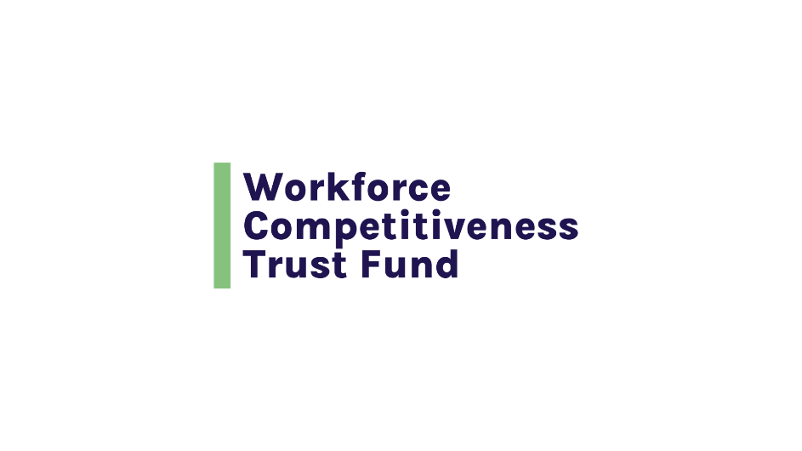

**APPLICATION PACKAGE / GENERAL AND ADMINISTRATIVE REQUIREMENT**

|  |  |
| --- | --- |
| **QUESTION** | **ANSWER** |
| Is it a requirement to apply to the Program Design grant before applying for a WCTF Implementation grant? | No, the Program Design grant is not a requirement to submit a WCTF Implementation grant. |
| Are there different Communities of Practice for the Program Design Grant and Donnelly Success Grants, or are they shared? | They will have separate Communities of Practice. |
| How does an organization schedule an appointment during office hours with Commonwealth Corportation staff? | Office hours are posted on the RFP page on our website; individuals requesting a Q&A session will be invited to schedule office hours from available time slots. |
| What is the timeframe for a program design contract? | Either 3 months or 6 months. |
| What is the anticipated timeline for being awarded a Program Design grant and planning to submit and begin a Donnelly-funded project? | Program Design awardees can anticipate a contract start date approximately 3 months after the submission due date. They would be eligible to submit a Donnelly Success Implementation Grant proposal at the completion of Program Design activities, assuming there is an open Donnelly Success Implementation Grant RFP at that time. |
| What type of letters of support are needed for a Program Design grant application? | Some examples are: interested or supportive employer partners, community partners, education or training partners, MassHire Career Centers or MassHire Workforce Boards. Formal MOU/MOAs are not a requirement of the Program Design application. |
| What are the expectations of a program design grantee during the grant period? | The expectations are that the grantee will participate in 3-4 Community of Practice meetings, meet monthly with a Commonwealth Corportation Program Manager for Technical Assistance sessions, complete and update a program design outline and submit a Donnelly Success Grant Implementation proposal as the final product of the program design grant. |

**ELIGIBLE LEAD APPLICANTS AND PARTNER ORGANIZATIONS**

|  |  |
| --- | --- |
| **QUESTION** | **ANSWER** |
| Does the Program Design grant need the two employer partners? | No. The Program Design grant can support work developing employer partnerships. |
| Are current WCTF-Donnelly grantees eligible for a Program Design grant? | Yes, any eligible lead applicant organization can apply for a Program Design grant, including grantees actively receiving WCTF funds. Active grantees should consider timeline and capacity to manage additional grants. |
| Can one community-based organization apply for two different Program Design Grants if the programs and program designs are different? | Yes, one organization is welcome to apply for multiple Program Design grants, but proposals are not guaranteed to be funded. |
| If I am the licensed owner of two organizations, each focused on serving a community in need in a different capacity, can I apply for the Program Design grant as one organization and later apply for the Donnelly grant as the other organization? | Yes, as long as both organizations meet the eligibility requirements outlined in the RFP. |

**BUDGET AND GRANT AWARD**

|  |  |
| --- | --- |
| **QUESTIONS** | **ANSWER HERE** |
| Is there a match requirement for the Program Design grant? | The match can be used for project staff directly working on the program, equipment, space rental, etc required for the program that are paid for through another funding source, employer in-kind and cash contributions to the program, and in-kind and cash contributions to the program from other partners.  Match detail must be provided in the budget narrative; there is no restriction on what can be covered by grant funds vs the match. |
| Can funds be used for bringing partners together for the planning grant? | Yes. |
| For the Donnelly Success Implementation grant, what types of transportation costs can be covered? | Examples of Participant Transportation costs that can be covered with WCTF/Donnelly Grant Implementation Funds are bus or T passes, ride-share costs, and gas costs.  In some instances, WCTF grantees have covered the costs of unexpected or emergency transportation issues a participant may experience, such as repairing a flat tire, to support them through completion of a training program. The cost of support services is not covered through the Program Design Grant. |
| For the Donnelly Success Implementation Grant, what types of childcare costs can be covered? | Tuition to a childcare center, the costs of onsite childcare, or the cost of in-home services, when provided by a licensed childcare provider. The cost of support services is not covered through the Program Design Grant. |
| For the Donnelly Success Implementation Grant, are we able to build in case management to help participants connect to continued support services that will address barriers to maintaining employment? | For post-placement case management support, grantees may use implementation funds as long as these costs are incurred within the contracted grant period. The cost of support services is not covered through the Program Design Grant. |

**FUNDING PRIORITIES / TARGET OCCUPATION(S)**

|  |  |
| --- | --- |
| **QUESTIONS** | **ANSWER HERE** |
| Will Commonwealth Corporation identify any occupations as statewide priority occupations? Specifically, will Commonwealth Corporation keep Early Education Teachers and Commercial Drivers (truckers) as priority occupations irrespective of regionally identified occupations? | Commonwealth Corportation does not identify statewide priority occupations. The Governor’s Workforce Skills Cabinet may identify statewide priorities. For the current RFP, the Skills Cabinet has identified Healthcare and Information Technology as statewide priorities. Applicants are encouraged to review their Regional Blueprint to identify occupations listed as “prioritized” or “critical but not prioritized” in their respective region(s).  <https://www.mass.gov/lists/regional-workforce-blueprints> |

**TRAINING PROGRAM OUTCOMES**

|  |  |
| --- | --- |
| **QUESTION** | **ANSWER** |
| What is the outcome of the design grant? | The goal is to submit a Donnelly Success Implementation Grant application. |
| For participants who are already employed, how do we measure and track successful outcomes? | (Regarding WCTF/Donnelly Success Implementation funding) Incumbent participants are expected to receive a $2+ hour wage gain as a result of completing the training program. If that is not a possible outcome, we will review alternative proposals and allow for some flexibility under certain circumstances in which participants may receive the non-monetary equivalent of this targeted outcome such as a promotion or an incremental wage gain, or a combination of a wage gain and other additional benefits. |
| If a participant starts their own business following the training, can that be considered an acceptable or positive outcome? | Historically, this has not been counted as a successful outcome of the training program. We are open to an exploratory discussion around the parameters and documentation requirements to measure self-employment as a successful outcome. |

**TRAINING /PROGRAM DESIGN**

|  |  |
| --- | --- |
| **QUESTION** | **ANSWER** |
| How would you suggest a program include ESOL into a training planning or implementation grant? | Commonwealth Corportation cannot fund a standalone ESOL program with WCTF funds but encourages grantees to include ESOL programming which may take the form of contextualized ESOL, integrating ESOL into occupational skills training, providing ESOL as a feeder to occupational skills training and co-teaching content with an instructor with expertise in the technical and occupational skills and an instructor with expertise in ESOL. |