**SECTOR PARTNERSHIP**

**DEVELOPMENT TOOLS AND RESOURCES**

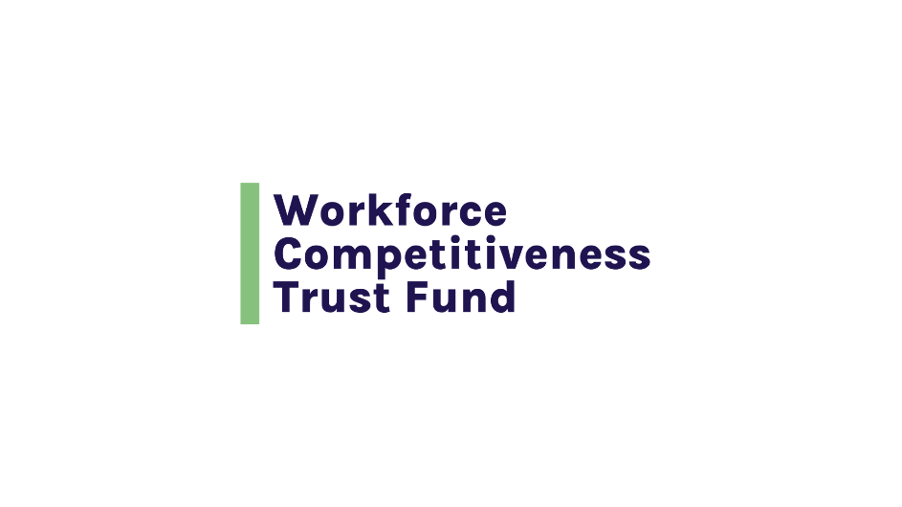

**INTRODUCTION**

**Sector Partnership Development Tools and Resources**

**The tools and resources listed below are intended to support the development and sustainability of workforce development partnerships.**

[**Sector Program Design Approach**](https://commcorp1.sharepoint.com/:w:/s/ESOLFSRsFY24-24204075-OeschMartha/EXZ1wfdPEqlFgVuyQrp2sjYBA2ouwW6_jGs4G2cFFB3Elg?e=UjIq3u)**, Commonwealth Corporation**

**A step-by-step guide to developing an industry sector partnership, with specific suggestions for each step of the process:**

**Step 1** → Identify demand

**Step 2** → Assess regional training and placement capacity for the target population

**Step 3** → Recruit business partners

**Step 4** → Recruit all other necessary partners

**Step 5** → Develop a shared program development work plan and MOA among partners

**Step 6** → Design the program

**Step 7** → Develop your data collection and analysis capacity

**Step 8** → Test the program

**Step 9** → Assess and redesign the program

**Step 10** → Test the program again

[**Next Generation Sector Partnerships**](https://static1.squarespace.com/static/57ebae4d5016e1191947196b/t/64527d0f9d11d911ddd31501/1683127575765/Training%2BManual-2023.pdf)**, Training Manual, Institute for Networked Communities, 2020**

**This Training Manual comprises six modules:**

**Module 1:** The Step-by-Step Process of Building Next Gen Sector Partnerships

**Module 2:** Coordinating Business Services and Outreach

**Module 3:** Serving Job Seekers and Students on the Front Line

**Module 4:** Connecting Industry-led Partnerships to Career Pathway Systems

**Module 5:** Success Metrics of Next Gen Partnerships

**Module 6:** State Roles and Responsibilities for Next Gen Success

**Module 1 (Pages 8-12) is the most directly relevant to partnership development. It takes you through 6 steps in partnership building:**

**Step 1** → Build your Regional Support Team & Make the Case for a New Approach

**Step 2** → Define the Scope of the Industry Focus

**Step 3** → Prepare to Launch

**Step 4** → Launch

**Step 5** → Move to Action: Organize the Aftermath and Begin Implementation

**Step 6** → Sustain and Evolve

[**Toolkit for Memorandums of Understanding, Industry & Community Workforce Partnerships**](https://dlt.ri.gov/sites/g/files/xkgbur571/files/documents/pdf/realjobs/Partnership-MOU-Tool-Kit_Final.pdf)**, Rhode Island Department of Labor and Training**

**The toolkit provides a framework for the development of a Memorandum of Understanding among workforce partners. Its content is in:**

**Section 1:** Toolkit for MOUs

**Section 2:** Building a Foundation

**Section 3:** Drafting the MOU

**The appendices include worksheets with suggested questions and frameworks that walk the user through phases of development. The toolkit also provides sample MOUs.**

* Build the Foundation
* Intent, Goals and Responsibilities
* Terms of Agreement
* Attachments
* Final Authorization

[**Partnerships: A Workforce Development Practitioner’s Guide**](https://commcorp.org/wp-content/uploads/2016/07/resources_2013-05-workforce-development-practitioners-guide.pdf)**, Commonwealth Corporation**

**The Practitioner’s Guide provides an in-depth roadmap for forming, leading and staffing, managing and sustaining industry sector training partnerships. The Guide contains elements designed to be useful to practitioners, including:**

* Things to Remember (Key questions and action steps)
* Sample in Practice (partnership examples)
* Take it to Go (tools and templates)
* Tips
* Tables
* Case Study (in-depth look at an example)

[**Toolkit for Developing High-Performing Industry Partnerships**](https://nationalfund.org/industry-partnership-toolkit/)**, National Fund for Workforce Solutions and the Corporation for a Skilled Workforce**

**The toolkit organizes key practices and indicators of success around five characteristics:**

* Employment and Industry Engagement
* Data-Informed Strategy and Continuous Learning
* Stakeholder Engagement
* Racial Equity and Inclusion
* Operational Capacity

The toolkit begins with a self-assessment of an industry partnership.